# ShopCart-Ecommerce Site Using Java & Spring Boot

A Major Project Report

Submitted in Partial Fulfilment of Requirement

for The Award of a Degree of

**Bachelor of Technology**

**(Electronics and Communication Engineering)**

To

Himachal Pradesh Technical University, Hamirpur



Submitted by:

**Satish Bhatt** (1902041014)



**Submitted To**

**Er. Sandeep Thakur**

**(OIC ECE)**

Department of Electronics and Communication Engineering

Atal Bihari Vajpayee Government Institute of Engineering and Technology

Pragatinagar – 171202, Shimla

June 2023

**DECLARATION**

I **Satish Bhatt**, student of Bachelor of Technology Electronics & Communication Engineering Department, Atal Bihari Vajpayee Government Institute of Engineering and Technology, Pragatinagar Shimla, having **Roll number 1902041014**, session 2019-2023, hereby declare that the Project entitled “**ShopCart-Ecommerce Site**”, submitted to the Electronics & Communication Engineering Department as partial fulfillment of the requirements for the award of the degree of Bachelor of Technology, has been carried out by me under the guidance of **Mrs. Anju Malhotra** (Software Developer, Pisoft Informatics).This is an original piece of work and has not formed the basis for the award of any other degree of any other college.

Dated: 24/06/23 Satish Bhatt

Place: ABVGIET Pragatinagar BTech ECE 8th

(1902041014)

**CERTIFICATE**



**ACKNOWLEDGMENT**

My sincere efforts have made me accomplish the task of completing this project. I have taken an effort in this project. However, it would not have been possible without the kind support and help of many individuals. I would like to extend my sincere thanks to all of them.

It has been great honor and privilege to undergo training at **Pisoft Informatics Pvt. Ltd.** I am highly indebted to my project guide **Mrs. Anju Malhotra** for his valuable guidance and constant supervision as well as for providing necessary information regarding the project and for his support in completing this project.

His constant guidance and willingness to share his vast knowledge made me understand this project and its manifestations in great depth and helped me to complete the assigned tasks on time.

I would like to express my gratitude towards my **parents** for their kind corporation and encouragement which helped me in the completion of this project.

**ABSTRACT**

The project report presents the development and implementation of "ShopCart – Ecommerce Site". ShopCart is an innovative and user-friendly e-commerce platform designed to provide a seamless shopping experience for customers. Our platform offers a wide range of products from various categories, allowing shoppers to conveniently browse, select, and purchase items from the comfort of their homes. With a sleek and intuitive interface, ShopCart offers a visually appealing and engaging shopping environment. Customers can easily search for products, view detailed descriptions and images, and compare prices and features. The platform is equipped with advanced filtering and sorting options to help users find their desired items quickly. ShopCart prioritizes security and privacy, ensuring that customer information and payment details are protected through robust encryption protocols. Multiple secure payment options are available, giving customers flexibility and peace of mind during transactions. This feature enhances the overall shopping journey, making it easier for customers to discover new products and promotions. ShopCart also supports a user-friendly seller interface, allowing merchants to set up their online stores effortlessly. Sellers can easily manage their inventory, track orders, and communicate with customers through our integrated messaging system. With its commitment to excellence in customer experience, security, and convenience, ShopCart aims to become the go-to destination for online shopping, empowering customers and sellers alike in the digital marketplace.

**TABLE OF CONTENT**

|  |  |  |  |
| --- | --- | --- | --- |
| **Chapter No.** |  | **Title**  Title Page | **Page No.**  i |
|  |  | Declaration | ii |
|  |  | Certificate | iii |
|  |  | Acknowledgement | iv |
|  |  | Abstract | v |
|  |  | Table of Content | vi-ix |
|  |  | List of Figures | x-xi |
| **Chapter 1** |  | **Introduction** | **1-7** |
|  | 1.1 | Company Profile | 1-2 |
|  | 1.2 | Project Introduction | 4 |
|  | 1.3 | Aim | 5 |
|  | 1.4 | Objective | 6 |
|  | 1.5 | Advantages | 6-7 |
| **Chapter 2** |  | **Literature Review** | **8-9** |
|  | 2.1 | Introduction | 8 |
|  | 2.2 | E-commerce Platform & Online Shopping | 8 |
|  | 2.3 | User Experience Design in E-commerce | 8 |
|  | 2.4 | Security Measures in E-commerce | 8 |
|  | 2.5 | Inference Drawn | 9 |
| **Chapter 3** |  | **Methodology** | **10-11** |
|  | 3.1 | Requirement Analysis | 10 |
|  | 3.2 | System Design | 10 |
|  | 3.3 | Frontend Development | 10 |
|  | 3.4 | Backend Development | 10 |
|  | 3.5 | Database Design & Implementation | 11 |
|  | 3.6 | Testing and Quality Assurance | 11 |
|  | 3.7 | Project Management | 11 |

|  |  |  |  |
| --- | --- | --- | --- |
| **Chapter 4** |  | **Technology** | **12-25** |
|  | 4.1 | Frontend | 12-17 |
|  |  | 4.1.1 HTML | 12-133 |
|  |  | 4.1.2 CSS | 14-15 |
|  |  | 4.1.3 JavaScript | 16-17 |
|  |  | 4.1.4 Bootstrap | 17-18 |
|  | 4.2 | Backend | 19-25 |
|  |  | 4.2.1 JAVA | 19-21 |
|  |  | 4.2.2 Spring Boot | 21-23 |
|  |  | 4.2.3 MySql | 23-25 |

|  |  |  |  |
| --- | --- | --- | --- |
| **Chapter 5** |  | **System Requirement** | **26** |
|  | 5.1 | Hardware Requirement | 26 |
|  | 5.2 | Software Requirement | 26 |

|  |  |  |  |
| --- | --- | --- | --- |
| **Chapter 6** |  | **Platform** | **27-30** |
|  | 6.1 | Spring Tool Suite | 27 |
|  | 6.2 | Features | 28-30 |

|  |  |  |  |
| --- | --- | --- | --- |
| **Chapter 7** |  | **Website** | **31-54** |
|  | 7.1 | Role Base Authentication with Spring Security | 31-34 |
|  |  | 7.1.1 Registration | 31 |
|  |  | 7.1.2 Login | 32-33 |
|  |  | 7.1.3 Role Based Authentication | 33-34 |
|  | 7.2 | Admin Section | 34-43 |
|  |  | 7.2.1 Features of Admin Section | 35-43 |
|  | 7.3 | Customer or User Section | 44-51 |
|  | 7.4 | About us | 51-52 |
|  | 7.5 | Contact us | 53-54 |

|  |  |  |  |
| --- | --- | --- | --- |
| **Chapter 8** |  | **Spring Boot Project** | **56-68** |
|  | 8.1 | Spring Boot Architecture | 56 |
|  | 8.2 | Spring Boot Float Architecture | 57 |
|  | 8.3 | Spring Intitalizr | 58 |
|  | 8.4 | Generating a Project | 59 |
|  | 8.5 | Creating a Spring Boot Project | 59-64 |
|  | 8.6 | Spring Boot Application Property | 64-65 |
|  | 8.7 | Spring Boot Project-Code &Folder Structure | 65-68 |

|  |  |  |  |
| --- | --- | --- | --- |
| **Chapter 9** |  | **Thymeleaf** | **69-71** |
|  | 9.1 | Introduction | 69 |
|  | 9.2 | Thymeleaf Template | 69-71 |

|  |  |  |  |
| --- | --- | --- | --- |
| **Chapter 10** |  | **Project Code** | **72-93** |
|  | 10.1 | Frontend Code HTML and Thymeleaf | 7-93 |

|  |  |  |  |
| --- | --- | --- | --- |
| **Chapter 11** |  | **Future Scope, Result &Conclusion** | **94-95** |
|  | 11.1 | Future Scope | 93 |
|  | 11.2 | Conclusion | 93-94 |
|  | 11.3 | Result | 95 |

|  |  |  |  |
| --- | --- | --- | --- |
| **Chapter 12** |  | **References** | **96** |
|  |  | **Industrial Project Evaluation Sheet** |  |
|  |  | **Industrial Project Weekly Work Diary** |  |

**LIST OF FIGURES**

|  |  |  |
| --- | --- | --- |
| **Fig. No.** | **Figure Name** |  |
| 1.1  1.2  6.1  6.2  7.1  7.2  7.3  7.4  7.5  7.6  7.7  7.8  7.9  7.10  7.11  7.12  7.13  7.14  7.15  7.16  7.17  7.18  7.19  7.20  7.21  7.22  7.23  7.24  7.25  7.26  8.1  8.2  8.3  8.4  8.5  8.6  8.7  8.8 | Figure-1.1(Logo) 1  Figure-1.2 (Services Provided by Pisoft) 2  Figure-6.1(Spring Tool Suite) 27  Figure-6.2 (Spring Suite Tool Interface) 28  Figure-7.1(Sign In Form) 32  Figure-7.2(Log In Form) 33  Figure-7.3(Admin Dashboard) 35  Figure-7.4(Admin Features) 35  Figure-7.5(Add Category) 36  Figure-7.6(Add Product) 37  Figure-7.7(Add Vendor) 38  Figure-7.8(Add Color) 39  Figure-7.9(Add Brands) 39  Figure-7.10(Add Payment Modes) 40  Figure-7.11 (Purchase and Purchase List) 41  Figure-7.12 ( Add Product Detail) 42  Figure-7.13(Stock List) 43  Figure-7.14(Stock Product View) 43  Figure-7.15 (Customer’s Profile) 44  Figure-7.16 (Website Home Page) 45  Figure-7.17 (Customer Profile Features) 46  Figure-7.18 (Address Page) 46  Figure-7.19 (Website Cart) 47  Figure-7.20 (Wishlist) 48  Figure-7.21 (Website Shop) 49  Figure-7.22 (Customer’s Payment Option Page) 50  Figure-7.23 (Customer’s Order Page) 50  Figure-7.24 (Product Detailed View) 51  Figure-7.25 (About Us Page) 52  Figure-7.26 (Contact Us Page) 55  Figure-8.1 (Spring Boot Architecture) 56  Figure-8.2 (Spring Boot Flow Architecture) 57  Figure-8.3 (Spring Initializr UI) 58  Figure-8.4 (Spring Initializr project generation) 60  Figure-8.5 (Project Structure) 61  Figure-8.6 (Run As-Java Application) 64  Figure-8.7 (Spring Project Started) 64  Figure-8.8 (application.Properties file) 65 |  |

**Chapter-1**

**INTRODUCTION**

* 1. **COMPANY PROFILE**

**Pisoft Informatics Pvt. Ltd.** is a rapidly growing Mohali-based IT company, providing ERP Solutions, Software Development, Website Development, Design & Implementation, Web Services **Figure-1.1**(Logo) Domain Registration, Hosting, Networking, AMC’s and Online/Offline Technical Support.

This company provides a web-based management system that is **“PisoftERP”.** It is used by companies to automate their businesses and manage their business-related tasks with more ease. As we know that different businesses have variations in their way of working so PisoftERP have sub-categories for their ERP system. This ensures businesses opt for the ERP that suits their business better. For example Finance Service Management ERP (FSME) for any finance-related business and Education System Management ERP (ESME) for any educational institute, college, or university. In a nutshell, PisoftERP deals in majorly 6 industries to provide ERP solutions. It involves Finance, Education, Tour & Travel, Automobile Industry, Medical & healthcare, and Service Industry.

pisoftERP is a web-based management automation Enterprise Application that assure smooth administration and management of all the activities with greater flexibility and ensures better interaction between all stakeholders and with an ease to make effective managerial decisions by reducing the gap between information and the users to maintain faster communications. Designed for better interaction between stakeholders by handling information gracefully and does not required much efforts to understand usage even by a non-technical user and reducing paper work.

The entire system is designed and developed in such a way that anyone with basic knowledge of computers and email can start using PisoftERP and become familiar within ten minutes of their first login by using any internet connected device.

Company’s efficient and experienced team is a greatest resource with latest infrastructure that houses a team of young and competitive professionals having experience in providing dedicated and high-end solutions to our clients.

**Specialties:**

ERP Solutions, Web Development, Web Designing, Business Automation System, IT Support, Cloud based Automation System, Enterprise Resource Planning, Industrial Training, Web Applications, Mobile Applications, and Web Hosting.

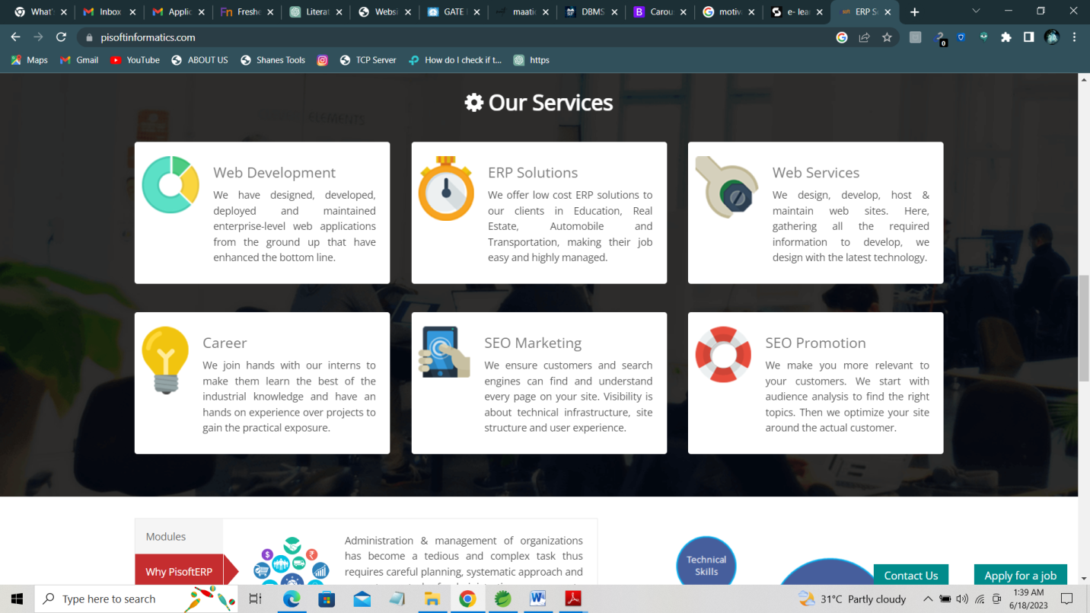

**Figure-1.2** (Services Provided by Pisoft)

**Website:** <https://pisoftinformatics.com/>

**Phone:** [8288029930Phone number is 8288029930](tel:8288029930)

**Industry:** IT Services and IT Consulting

**Headquarters:** Mohali, Punjab

**Founded:** 2015

[**Address**](https://www.google.com/search?rlz=1C1SQJL_enIN881IN881&sxsrf=APwXEdf4SRD66Yk_SJz1RIAOOzNFVI_N_Q:1687031210939&q=pisoft+informatics+pvt+ltd.+address&ludocid=15126244461432911093&sa=X&ved=2ahUKEwin_LWAicv_AhUfcmwGHVlSCeEQ6BN6BAhEEAI)**:** F-468, Phase 8B, Focal Point, Sahibzada Ajit Singh Nagar, Punjab 160071

* 1. **PROJECT INTRODUCTION**

The following project introduces ShopCart, an innovative e-commerce platform that aims to revolutionize online shopping for customers. In today's digital age, e-commerce has experienced remarkable growth, offering convenience, variety, and accessibility to shoppers. Recognizing this trend, ShopCart seeks to provide a comprehensive online shopping experience, catering to the diverse needs and preferences of modern consumers.

The primary objective of ShopCart is to create a user-friendly and seamless platform where customers can browse, select, and purchase a wide range of products. By curating an extensive selection of high-quality products, we strive to become a go-to destination for online shopping.

ShopCart distinguishes itself through its intuitive interface, ensuring effortless navigation for customers. Our design prioritizes ease of use, enabling shoppers to find their desired products quickly and efficiently. Advanced search and filtering options empower users to refine their search results based on specific criteria, resulting in a personalized shopping experience.

Security is paramount in the e-commerce industry, and ShopCart takes this seriously. We implement robust encryption protocols to protect customer data and payment information, fostering trust and confidence in every transaction. By integrating reputable payment gateways, we offer multiple secure payment options, giving customers flexibility and peace of mind during their purchases.

To enhance the shopping experience, ShopCart leverages machine learning algorithms to provide personalized recommendations. By analyzing customer preferences and browsing history, our platform suggests relevant products, enabling users to discover new items of interest easily. This feature creates a tailored experience for each customer, making their shopping journey more engaging and enjoyable.

Furthermore, ShopCart aims to support sellers by offering a user-friendly seller management dashboard. Sellers can easily set up their online stores, manage inventory, track orders, and communicate with customers through our integrated messaging system. We strive to streamline the seller's experience, empowering them to grow their businesses and connect with a wider customer base.

Throughout this project report, we will explore the architecture, functionality, and user engagement strategies implemented within ShopCart. We will also delve into the existing research and literature surrounding e-commerce platforms, user experience design, security measures, and the evolving trends in the online shopping landscape. By analyzing the effectiveness of ShopCart in meeting customer needs and driving business growth, we aim to highlight the value and impact of our e-commerce platform.

In conclusion, this project report provides an overview of ShopCart, showcasing its objectives, features, and its role in transforming the online shopping experience. The subsequent sections will delve into the platform's technical aspects, user interactions, and the analysis of its performance, ultimately demonstrating how ShopCart aims to redefine the way people shop online.

* 1. **Aim**

The aim of the ShopCart project is to create an innovative and user-friendly e-commerce platform that revolutionizes the online shopping experience for customers. Our primary objectives include:

**Enhancing Convenience:** ShopCart aims to provide a convenient and seamless online shopping experience for customers. By offering a diverse range of products across multiple categories, customers can find everything they need in one place, eliminating the need to visit multiple websites or physical stores.

**Providing Variety and Choice:** We aim to curate an extensive catalog of high-quality products to cater to the diverse preferences and needs of customers. By offering a wide selection of items, ShopCart ensures that customers have access to a range of choices, enabling them to find the perfect products that suit their tastes and requirements.

**Prioritizing User-Friendly Interface:** ShopCart places a strong emphasis on creating a user-friendly interface that is intuitive and easy to navigate. By designing a platform with seamless navigation and advanced search and filtering options, customers can find their desired products quickly and efficiently, enhancing their overall shopping experience.

**Ensuring Security and Trust:** Security is a top priority in e-commerce. ShopCart implements robust encryption protocols and integrates trusted payment gateways to protect customer data and payment information. By prioritizing security, we aim to build trust and confidence among customers, ensuring safe transactions and safeguarding their personal information.

Personalized Shopping Experience: ShopCart leverages machine learning algorithms to provide personalized recommendations based on customer preferences and browsing history. By suggesting relevant products, we aim to enhance the shopping journey, helping customers discover new items and promotions tailored to their interests.

**Supporting Sellers:** ShopCart aims to support sellers by offering a user-friendly seller management dashboard. Sellers can easily set up their online stores, manage inventory, track orders, and communicate with customers. Our platform empowers sellers to grow their businesses and connect with a broader customer base.

**Fostering Engagement and Satisfaction:** Through interactive features such as quizzes, gamified elements, and algorithm visualizers, ShopCart aims to foster engagement and satisfaction among customers. By providing an immersive and enjoyable shopping experience, we strive to exceed customer expectations and ensure their continued loyalty.

* 1. **Objective**

The objective of the ShopCart project is to develop and establish an innovative e-commerce platform that achieves the following goals:

**Create a Seamless Shopping Experience:** The primary objective is to provide customers with a seamless and user-friendly online shopping experience. This includes intuitive navigation, advanced search and filtering options, and a visually appealing interface that enhances convenience and ease of use.

**Offer a Wide Range of Products:** ShopCart aims to offer a diverse and comprehensive catalog of products across various categories. The objective is to provide customers with a vast selection of high-quality items, catering to different preferences and needs, ensuring that they can find what they are looking for on the platform.

**Ensure Security and Trust:** The project objective is to prioritize the security of customer information and payment details. Implementing robust encryption protocols and integrating trusted payment gateways, ShopCart aims to build trust and provide a secure environment for customers to make their purchases confidently.

**Personalize the Shopping Experience:** ShopCart aims to leverage machine learning algorithms to provide personalized recommendations based on customer preferences and browsing history. The objective is to enhance customer satisfaction by offering tailored product suggestions that align with their interests and preferences.

**Support Seller Growth:** ShopCart aims to support sellers by providing a user-friendly seller management dashboard. The objective is to offer sellers the tools and resources they need to easily manage their online stores, track orders, communicate with customers, and grow their businesses effectively.

**Foster Customer Engagement and Satisfaction:** ShopCart intends to implement interactive features such as quizzes, gamification elements, and algorithm visualizers to enhance customer engagement and satisfaction. The objective is to create an immersive shopping experience that keeps customers engaged and satisfied throughout their journey on the platform.

**Continuously Improve and Innovate:** ShopCart aims to embrace continuous improvement and innovation. The objective is to stay at the forefront of the e-commerce industry by adopting emerging technologies, incorporating customer feedback, and implementing new features and functionalities that enhance the overall shopping experience.

* 1. **Advantages**

Advantages of ShopCart:

1. Convenience
2. Wide Product Selection
3. User-Friendly Interface
4. Secure Transactions
5. Personalized Recommendations
6. Seller Support
7. Continuous Improvement

Overall, ShopCart offers the advantages of convenience, a wide selection of products, user-friendly interface, secure transactions, personalized recommendations, seller support, enhanced engagement, and continuous improvement, creating a positive and enjoyable online shopping experience for customers.

**Chapter-2**

**LITERATURE REVIEW**

* 1. **INTRODUCTION**

The literature review aims to explore existing research, studies, and scholarly works related to e-commerce sites and online shopping. By reviewing the literature, we can gain insights into the effectiveness of e-commerce platforms, user experience design, security measures, personalization strategies, social commerce, mobile commerce, and emerging trends in the industry.

* 1. **E-commerce Platforms and Online Shopping**

Numerous studies have highlighted the growing significance of e-commerce platforms in the modern business landscape (Chaffey et al., 2020; Liang & Huang, 2019). These platforms provide convenience, accessibility, and a wide range of product choices to customers, leading to increased online shopping behavior and sales (Kotler & Keller, 2021).

**References:**

* Liang, X., & Huang, L. (2019). The Effect of User Experience on Online Shopping Behavior: A Literature Review. International Journal of Electronic Commerce, 23(2), 226-247.
  1. **User Experience Design in E-commerce**

User experience (UX) design plays a crucial role in enhancing the usability and satisfaction of e-commerce sites (Liu et al., 2020; Hassenzahl, 2018). Studies have shown that well-designed interfaces, intuitive navigation, fast loading times, and personalized experiences positively influence user engagement, trust, and purchase intention (Tractinsky et al., 2019).

**References:**

* Liu, Y., et al. (2020). Investigating Factors Influencing the User Experience of E-commerce Websites. Computers in Human Behavior, 111, 106411.
* Hassenzahl, M. (2018). User Experience (UX): Towards an Experiential Perspective on Product Quality. In Product Experience (pp. 57-70). Springer.
  1. **Security Measures in E-commerce**

Security is a critical aspect of e-commerce transactions. Research has focused on examining security measures, such as encryption, secure payment gateways, and user authentication, to build trust and protect customer information (Al-Hakim et al., 2017; Gupta & Malik, 2021). Studies have emphasized the importance of robust security systems to mitigate risks and ensure secure online transactions.

**References:**

* Gupta, M., & Malik, S. (2021). E-commerce Security Measures: A Systematic Review. International Journal of Electronic Commerce, 25(2), 1-45.
  1. **Inference Drawn**

Based on the literature review, we can conclude that e-commerce platforms have become increasingly important for businesses, as they provide convenience and a wide range of products, leading to increased online shopping and sales. User experience design plays a crucial role in enhancing user engagement, trust, and purchase intention, and factors such as well-designed interfaces, intuitive navigation, fast loading times, and personalized experiences contribute to a positive user experience. Additionally, the review highlights the significance of robust security measures, including encryption and secure payment gateways, to protect customer information and build trust. Further research and implementation of effective strategies are necessary to address evolving technology and consumer behaviors in the e-commerce industry.

Top of Form

**Chapter-3**

**METHODOLOGY**

* 1. **Requirement Analysis:**

Conducted a comprehensive analysis of the requirements for the e-commerce site, including features such as user registration, product catalog, shopping cart, wish-list, admin section etc. Gathered feedback from potential users and stakeholders to understand their specific needs, preferences, and expectations.

* 1. **System Design:**

Designed the system architecture for the study portal, including the frontend and backend components. Utilized HTML, CSS, JavaScript, and Bootstrap for the frontend development, ensuring a responsive and user-friendly interface. Implemented the backend using Spring Boot and MySQL, designing the database schema to accommodate user accounts, cart items, wishlist.

* 1. **Frontend Development:**

Implemented the user interface (UI) using HTML, CSS, and JavaScript, following the design guidelines and wireframes. Developed responsive layouts, intuitive navigation, and interactive features. Integrated third-party libraries or frameworks for enhanced functionality, such as a JavaScript.

* 1. **Backend Development:**

Developed the backend functionalities using Spring Boot and MySQL. Implemented RESTful APIs to handle user authentication, data retrieval, and data storage. Integrated with the MySQL database to store and retrieve data. Implemented security measures such as password hashing and session management to protect user data.

* 1. **Database Design and Implementation**

Designed the database schema based on the requirements of the e-commerce site. Created tables for storing user information, product details, order data, and other relevant entities. Established relationships between tables, defined indexes for efficient data retrieval, and optimized the database queries. Implemented the database using a suitable database management system.

* 1. **Testing and Quality Assurance**

Conducted thorough testing of the e-commerce site to ensure its functionality, performance, and security. Performed unit testing, integration testing, and system testing to identify and fix any issues or bugs. Implemented security measures, such as input validation and protection against common vulnerabilities (such as SQL injection and cross-site scripting). Employed automated testing tools and techniques to streamline the testing process.

* 1. **Project Management**

Employed project management methodologies to ensure effective planning, scheduling, and coordination. Utilized project management tools for task management, collaboration, and progress tracking. Regularly communicated with the team members, monitored project milestones, and addressed any challenges or issues that arose during the development process.

**Chapter-4**

**TECHNOLOGY**

* 1. **Frontend**

The frontend of the "One Solution - Study Portal" was developed using a combination of HTML, CSS, JavaScript, and Bootstrap. These technologies were chosen to create an intuitive and user-friendly interface that provides a seamless learning experience for engineering students.

* + 1. **HTML**

HTML, short for Hypertext Markup Language, is the fundamental building block of the web. It provides the structure and formatting for creating web pages. HTML uses a series of tags to define different elements within a page, such as headings, paragraphs, images, links, and more. These tags allow developers to structure and organize content effectively.

In HTML, the structure is hierarchical, with elements nested inside one another. This hierarchical structure helps in organizing content into logical sections, improving readability and accessibility. HTML also supports the use of hyperlinks, allowing users to navigate between web pages and access resources within a website. Additionally, HTML provides support for including multimedia elements like images, videos, and audio, enabling developers to create engaging and interactive web content. By mastering the basics of HTML, developers can lay the foundation for building visually appealing and functional web pages.

**HTML (Hypertext Markup Language) has several important features that make it a crucial part of web development:**

1. **Structure and Semantics:** HTML provides a structural framework for organizing and presenting content on the web. It offers a set of predefined tags that define the purpose and meaning of each element, such as headings, paragraphs, lists, tables, forms, and more. This semantic markup improves accessibility, search engine optimization (SEO), and overall understanding of the content.

2. **Hyperlink and Navigation:** HTML enables the creation of hyperlinks, allowing users to navigate between web pages and access different resources. Hyperlinks are defined using the `<a>` tag, and they can link to other web pages, sections within the same page, external files, email addresses, and more. This feature enhances user experience and facilitates the exploration of information on the web.

3. **Multimedia Integration:** HTML supports the integration of multimedia elements, including images, videos, and audio files. Images are added using the `<img>` tag, videos using the `<video>` tag, and audio using the `<audio>` tag. These features enable developers to deliver rich and engaging content to users.

4. **Forms and User Input:** HTML provides form elements such as text fields, checkboxes, radio buttons, dropdown menus, and submit buttons. These elements allow users to input data, provide feedback, and submit information on web pages. Form data can be processed on the server side using server-side scripting languages like PHP or ASP.NET.

5. **Responsive and Mobile-Friendly Design:** With the introduction of HTML5, responsive web design has become easier to implement. HTML5 provides features like media queries, which allow developers to create websites that adapt to different screen sizes and devices. This ensures that web content is accessible and readable on desktops, laptops, tablets, and mobile devices.

6. **Cross-Browser Compatibility:** HTML is supported by all major web browsers, including Chrome, Firefox, Safari, and Internet Explorer/Edge. This compatibility ensures that web pages built with HTML can be accessed and displayed consistently across different browsers and platforms.

7. **Easy Integration with CSS and JavaScript:** HTML can be seamlessly integrated with CSS (Cascading Style Sheets) for styling and layout, and JavaScript for adding interactivity and dynamic functionality to web pages. This trio of technologies (HTML, CSS, and JavaScript) forms the foundation of modern web development.

* + 1. **CSS**

CSS (Cascading Style Sheets) is a powerful web technology that complements HTML by providing styling and presentation capabilities. It allows developers to define the visual appearance of HTML elements, controlling aspects such as colors, fonts, layouts, and animations. CSS separates the structure of the content (defined by HTML) from its presentation, providing flexibility and ease of maintenance.

With CSS, developers can apply styles to HTML elements individually or in groups. Styles can be specified directly within the HTML file using inline styles, or externally in a separate CSS file that is linked to the HTML document. This separation of styles from content promotes modularity and reusability, as the same CSS file can be applied to multiple HTML pages, ensuring consistent design and layout across an entire website.

**CSS (Cascading Style Sheets) offers a wide range of features that enable developers to style and enhance the appearance of HTML elements.**

1. **Selectors:** CSS provides a variety of selectors that allow developers to target specific elements for styling. Selectors can be based on element names, classes, IDs, attributes, and more. This flexibility enables precise control over which elements are affected by the defined styles.

2. **Box Model:** The CSS box model defines how elements are structured and rendered on a webpage. It includes properties such as margin, padding, border, and content width/height. These properties allow developers to control the spacing, borders, and dimensions of elements, shaping the layout of the page.

3. **Typography:** CSS allows developers to control the typography of text elements, including properties such as font family, size, weight, color, and alignment. With CSS, you can create visually appealing and readable text content.

4. **Colors and Backgrounds:** CSS provides various ways to specify colors and backgrounds for elements. It supports named colors, hexadecimal values, RGB, and HSL color notations. Background properties enable the inclusion of background images, gradients, and patterns.

5. **Layout and Positioning:** CSS offers powerful layout and positioning options to create different page structures. Flexbox and grid layout systems allow for flexible and responsive layouts, enabling elements to adjust based on screen size or device orientation.

6. **Transitions and Animations:**CSS provides the ability to apply transitions and animations to elements. Transitions allow smooth changes in property values, such as fading in/out or sliding effects. Animations enable the creation of more complex and dynamic effects, including keyframe-based animations.

7. **Media Queries:** CSS supports media queries, which allow developers to apply different styles based on the characteristics of the device or screen size. This feature enables responsive design, where the layout and styling of elements adapt to different screen resolutions and device types.

8. **Selectors and Pseudo-classes:** CSS provides selectors and pseudo-classes to target specific states or elements within a document. Pseudo-classes like `:hover`, `:active`, and `:focus` allow developers to apply styles when an element is interacted with or in a specific state.

* + 1. **JavaScript**

JavaScript is a high-level, interpreted programming language that is primarily used for web development. It is known for its versatility and widespread adoption, making it one of the most popular programming languages today.

JavaScript is a versatile and powerful programming language that adds interactivity and dynamic functionality to web pages. It allows developers to manipulate and control HTML elements, handle user interactions, perform calculations, fetch data from servers, and much more.

JavaScript's flexibility and extensive capabilities make it a fundamental language for web development. It empowers developers to create interactive user experiences, handle data manipulation, and connect with external resources, resulting in dynamic and feature-rich web applications.

**Here are some key features of JavaScript:**

1. **Event Handling:** JavaScript enables developers to respond to various user interactions, such as clicks, mouse movements, keyboard inputs, and form submissions. With event handling, developers can create interactive web experiences, validate user input, and trigger actions based on user actions.
2. **DOM Manipulation:** JavaScript provides access to the Document Object Model (DOM), which represents the structure of an HTML document. Developers can use JavaScript to manipulate and modify HTML elements, dynamically create or remove elements, change styles and attributes, and update content in real-time. This capability allows for dynamic updates and enhances the user experience.
3. **Data Manipulation:** JavaScript allows for the manipulation and transformation of data within web applications. It supports data types such as strings, numbers, arrays, and objects, along with built-in functions for performing operations on these data types. JavaScript also provides powerful methods for parsing and formatting data, making it suitable for data-driven web applications.
4. **Asynchronous Programming:** JavaScript supports asynchronous programming through features such as callbacks, promises, and async/await. Asynchronous operations allow developers to make requests to servers, retrieve data, and update the webpage without blocking the user interface. This enables the creation of responsive and interactive web applications.
5. **Error Handling:** JavaScript provides mechanisms for handling and managing errors during runtime. Developers can use try-catch blocks to catch and handle errors, preventing them from crashing the entire application. Error handling ensures that applications gracefully handle unexpected scenarios and provide informative error messages to users.
6. **Third-Party Library Ecosystem:** JavaScript has a vast ecosystem of third-party libraries and frameworks, such as React, Angular, and Vue.js, that provide additional functionalities and streamline the development process. These libraries offer ready-to-use components, improved state management, and enhanced performance, allowing developers to build complex web applications efficiently.
   * 1. **Bootstrap**

Bootstrap is a popular open-source front-end framework that simplifies web development and promotes responsive design. It provides a collection of CSS styles, JavaScript plugins, and pre-designed components that developers can utilize to create modern and visually appealing websites and web applications. Here are some reasons why Bootstrap is widely used:

1. **Responsive Design:** Bootstrap's grid system allows developers to create responsive layouts that adapt to different screen sizes and devices. By utilizing predefined classes, developers can easily arrange content and ensure that their websites look great on desktops, tablets, and mobile devices.

2. **Pre-designed Components:** Bootstrap offers a wide range of ready-to-use components, such as navigation bars, buttons, forms, carousels, modals, and more. These components follow a consistent design language, saving development time and ensuring a cohesive and professional look for the website.

3. **Customizable and Extensible:** While Bootstrap provides a comprehensive set of styles and components out of the box, it is highly customizable to suit individual project requirements. Developers can override default styles, modify variables, and create their own custom components to achieve a unique and personalized design.

4. **Cross-Browser Compatibility:** Bootstrap is designed to work seamlessly across different browsers and platforms. It handles many browser inconsistencies, ensuring consistent rendering and behavior across various environments. This saves developers from the hassle of writing browser-specific code.

5. **Community and Documentation:** Bootstrap has a large and active community of developers, making it easy to find resources, tutorials, and support. The official Bootstrap documentation provides comprehensive guidance and examples, making it easier for developers to learn and implement Bootstrap in their projects.

6. **Time and Cost Efficiency:** By leveraging Bootstrap's pre-built components and responsive grid system, developers can significantly reduce development time and effort. This efficiency translates into cost savings for projects with tight deadlines or limited resources.

Overall, Bootstrap's popularity stems from its ability to simplify the development process, provide responsive design capabilities, offer a variety of customizable components, and foster a strong community. It empowers developers to create visually appealing and mobile-friendly websites while saving time and effort in the process.

* 1. **Backend**

The backend of the "One Solution - Study Portal" project utilizes the Spring Boot framework and MySQL database management system to provide a robust and scalable foundation for the application. The backend is responsible for handling data storage, processing user requests, and managing the business logic. With Spring Boot, we leveraged its rapid development capabilities and built RESTful APIs to handle various functionalities, such as retrieving and storing notes, question papers, and user information. The MySQL database ensured efficient data management and retrieval, while user authentication and authorization mechanisms enhanced security. Additionally, integration with third-party services and performance optimization techniques were implemented to provide a seamless and efficient user experience. Overall, the backend of the project forms the backbone of the "One Solution - Study Portal," enabling data processing, business logic execution, and reliable service delivery to users.

* + 1. **JAVA**

Java is a widely used programming language known for its versatility, reliability, and platform independence. It was developed by Sun Microsystems (now owned by Oracle) and released in 1995. Here are some key features of Java:

1. Simple and Easy to Learn: Java was designed to be beginner-friendly and has a syntax similar to other popular programming languages like C++. Its straightforward and readable syntax, along with extensive documentation and abundant online resources, make it relatively easy to learn and use.

2. Platform Independence: One of the most notable features of Java is its "Write Once, Run Anywhere" principle. Java programs can run on any device or operating system with a Java Virtual Machine (JVM) installed, which provides a layer of abstraction between the Java code and the underlying hardware. This platform independence makes Java highly portable and versatile.

3. Object-Oriented Programming (OOP): Java is a fully object-oriented programming language, which means that it revolves around the concept of objects and classes. Encapsulation, inheritance, and polymorphism are integral parts of Java's OOP paradigm, allowing for modular and reusable code.

4. Memory Management: Java features automatic memory management through a garbage collector. The garbage collector automatically handles the allocation and deallocation of memory, freeing developers from managing memory manually. This reduces the risk of memory leaks and improves overall program stability.

5. Strong Type System: Java has a strong and static type system, which means that variables must be declared with their types at compile-time. This helps catch type-related errors early in the development process and ensures better code reliability.

6. Rich Standard Library: Java comes with a comprehensive and extensive standard library that provides a wide range of pre-built classes and APIs for common programming tasks. The standard library covers areas such as input/output operations, networking, file handling, multithreading, and more. It simplifies development by offering ready-to-use functionalities and reduces the need for writing code from scratch.

7. Concurrency Support: Java provides built-in support for concurrent programming through its threading and synchronization mechanisms. This allows developers to create multi-threaded applications that can perform tasks concurrently, improving performance and responsiveness.

8. Robust and Secure: Java places a strong emphasis on reliability and security. Its built-in exception handling, runtime type checking, and bytecode verification mechanisms help prevent errors and enhance program robustness. Additionally, Java's security features, such as the sandbox model and built-in security APIs, provide a secure environment for executing applications.

9. Community and Ecosystem: Java has a large and active developer community, which contributes to its vast ecosystem of libraries, frameworks, and tools. Popular frameworks like Spring, Hibernate, and JavaFX provide solutions for web development, database integration, and graphical user interfaces, among others. This thriving ecosystem offers developers a wealth of resources and options for building Java applications.

Java's features make it suitable for a wide range of applications, from desktop and web development to mobile and enterprise solutions. Its combination of simplicity, portability, strong typing, and extensive library support has contributed to its enduring popularity in the software development industry.

* + 1. **Spring Boot**

Spring Boot is a popular Java-based framework designed to simplify the development of standalone, production-grade Spring applications. It aims to provide developers with a faster and more efficient way to create robust, scalable, and easily deployable applications. Here are some key features and benefits of Spring Boot:

1. **Auto-configuration:** Spring Boot automatically configures the application based on the dependencies and libraries present in the classpath. It eliminates the need for manual configuration, reducing boilerplate code and allowing developers to focus on writing business logic.

2. **Embedded Server:** Spring Boot includes an embedded server, such as Tomcat, Jetty, or Undertow, which eliminates the need to deploy applications on a separate server. This makes it convenient to run and test applications with minimal setup.

3. **Starter Dependencies:** Spring Boot provides a vast collection of starter dependencies that simplify the management of project dependencies. Starters are pre-configured dependencies for specific functionalities, such as web applications, database access, security, and more. They ensure that all necessary libraries and configurations are included without manual intervention.

4. **Actuator:** Spring Boot Actuator provides built-in endpoints and monitoring capabilities to manage and monitor applications at runtime. It offers features like health checks, metrics, logging configuration, and more, allowing developers to gain insights into the application's behavior and performance.

5. **Spring Ecosystem Integration:** Spring Boot seamlessly integrates with the wider Spring ecosystem, including Spring MVC for web development, Spring Data for database access, Spring Security for authentication and authorization, and many more. This integration enables developers to leverage the extensive features and capabilities of the Spring framework.

6. **Production-Ready Features:** Spring Boot incorporates production-ready features such as advanced logging, exception handling, caching, security configurations, and database connection pooling. These features help developers build applications that are ready for deployment in a production environment with minimal additional configuration.

7. **Externalized Configuration:** Spring Boot allows developers to externalize configuration properties, such as database connections, server ports, or application-specific settings, into external files. This enables easy configuration management without the need to modify and recompile the code.

8. **DevOps Friendly:** Spring Boot's design principles promote DevOps practices. It supports containerization technologies like Docker, facilitates easy deployment to cloud platforms, and integrates with popular continuous integration and delivery (CI/CD) tools. This makes it well-suited for modern software development and deployment workflows.

9. **Community and Documentation:** Spring Boot benefits from a large and active community of developers. It has extensive documentation, tutorials, and community-driven resources that make it easier for developers to learn, troubleshoot, and share knowledge.

* + 1. **MySQL**

MySQL is an open-source relational database management system (RDBMS) that is widely used for storing, managing, and retrieving data. It is a popular choice for web applications, enterprise systems, and small to large-scale data-driven projects. Here are some key features and benefits of MySQL:

1**. Relational Database Management System:** MySQL follows the relational database model, which organizes data into tables with rows and columns. It provides a structured and efficient way to store and retrieve data, supporting complex queries and relationships between tables.

2. **Scalability and Performance:** MySQL is known for its scalability and performance capabilities. It can handle high volumes of data and concurrent connections efficiently. MySQL offers various optimization techniques, indexing mechanisms, and caching strategies to improve query execution and response times.

3. **Cross-Platform Compatibility:** MySQL is compatible with multiple operating systems, including Windows, Linux, macOS, and various Unix-like systems. This allows developers to deploy their applications on different platforms without major changes to the database setup.

4. **Ease of Use:** MySQL is designed to be user-friendly, offering a simple and intuitive command-line interface (CLI) as well as graphical user interface (GUI) tools like phpMyAdmin and MySQL Workbench. It provides SQL (Structured Query Language) as the standard language for interacting with the database, making it easy to learn and use for developers.

5. **Data Security:** MySQL offers robust security features to protect sensitive data. It supports user authentication, access control, and encryption mechanisms to ensure that only authorized users have appropriate access to the database. Additionally, it provides data backup and recovery options to prevent data loss in case of system failures.

6**. High Availability and Replication:** MySQL supports high availability and replication features, allowing developers to create redundant copies of the database for backup, fault tolerance, and load balancing. Replication enables data synchronization across multiple database servers, providing scalability and ensuring data integrity.

7**. Community and Support:** MySQL has a large and active community of developers and users. It benefits from extensive community-driven resources, documentation, forums, and online tutorials, making it easier to find solutions, share knowledge, and get support when needed.

8. **Integration and Compatibility:** MySQL integrates well with various programming languages and frameworks. It provides connectors and APIs for languages like Java, PHP, Python, and .NET, enabling seamless interaction between the application code and the database. It also supports standard protocols like ODBC and JDBC for easy integration with different systems.

9. **Cost-Effective Solution:** MySQL is an open-source database, which means it is free to use and distribute. It offers a cost-effective solution for businesses and projects with budget constraints, eliminating the need for expensive licensing fees associated with commercial database systems.

MySQL's features and benefits make it a versatile and reliable choice for managing data in various applications. Whether it's a small-scale website or a large enterprise system, MySQL provides the tools and capabilities to store, retrieve, and manipulate data efficiently and securely.

`

**Chapter-5**

**SYSTEM REQUIREMENT**

* 1. **Hardware Requirement**

- Processor: Intel Core i3 or higher

- RAM: Minimum 4GB (16GB recommended for better performance)

- Storage: At least 256GB SSD (Solid State Drive) for faster data access

- Display: Monitor with a resolution of 1280x800 or higher

- Network: Internet connection for software updates and online functionality

* 1. **Software Requirement**

- Operating System: Windows 10, macOS, or Linux (Ubuntu, CentOS, etc.)

- Java Development Kit (JDK): Version 8 or later

- Integrated Development Environment (IDE): Spring Tool Suite (STS), IntelliJ IDEA, or Eclipse

- Web Server: Apache Tomcat, Jetty, or any other compatible server

- Database Management System: MySQL (version 5.6 or higher) or MariaDB

- Web Browser: Google Chrome, Mozilla Firefox, or Safari for testing and debugging

- Version Control System: Git for source code management

- Build and Dependency Management: Apache Maven or Gradle

**Chapter-6**

**PLATFORM**

* 1. **Spring Tool Suite**

Spring Tool Suite (STS) is an integrated development environment (IDE) specifically designed for developers working with the Spring Framework. It is built on top of the Eclipse IDE, providing a rich set of features and tools that streamline the development process for Spring-based applications. STS offers seamless integration with the Spring ecosystem, making it an invaluable tool for developers to leverage the full power of the framework.

One of the key advantages of STS is its comprehensive support for Spring Boot. Spring Boot simplifies the setup and configuration of Spring applications, and STS provides dedicated features and wizards to create, configure, and deploy Spring Boot projects. With STS, developers can easily generate Spring Boot starters, manage dependencies, and take advantage of auto-configuration, allowing them to focus more on developing business logic rather than handling infrastructure concerns.

STS also offers advanced features for code assistance and refactoring, making it easier for developers to write clean and efficient code. It provides intelligent code completion, content assist, and quick-fix suggestions specific to Spring, helping developers navigate through their codebase with ease. Additionally, STS integrates seamlessly with testing frameworks like JUnit, facilitating efficient testing and debugging of Spring applications.

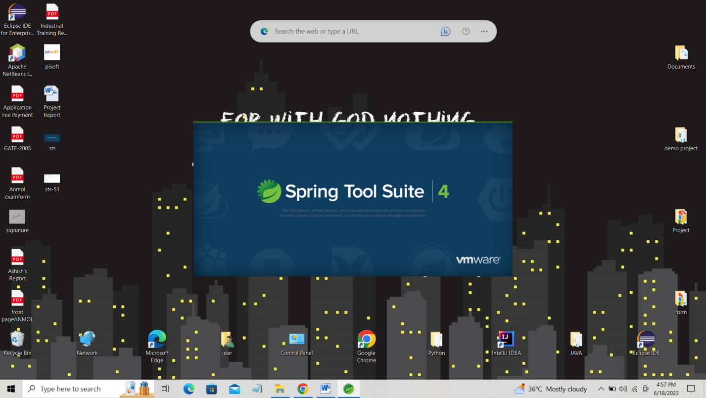

**Figure-6.1**(Spring Tool Suite)

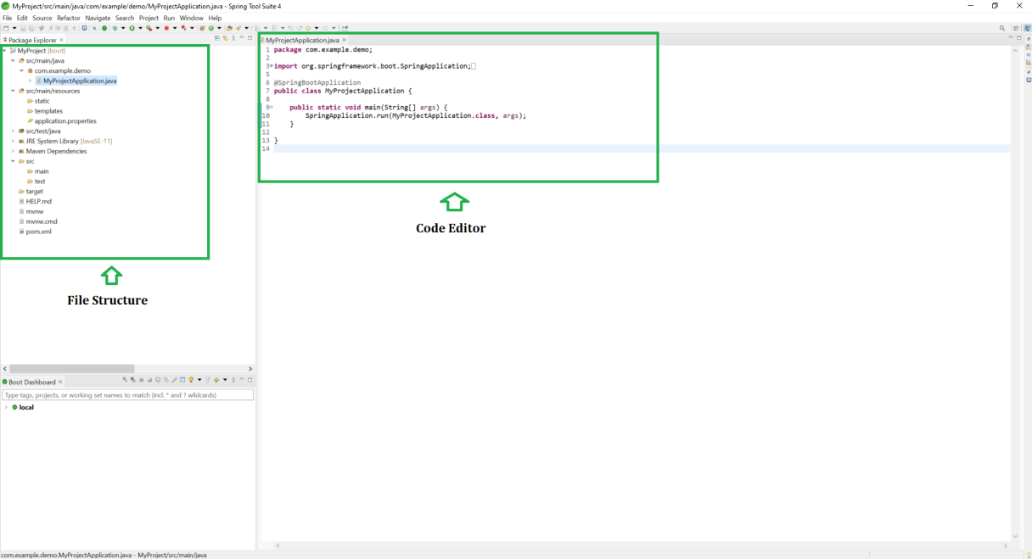

**Figure-6.2** (Spring Suite Tool Interface)

* 1. **Features**

It is based on the popular Eclipse IDE and provides additional features and plugins tailored for Spring developers. Here are some key aspects and features of Spring Tool Suite:

1. **Spring Framework Integration**: STS offers seamless integration with the Spring Framework, providing comprehensive support for creating, configuring, and managing Spring-based applications. It includes features like intelligent code completion, Spring-specific project templates, and wizards for setting up Spring configurations.

2. **Code Assistance and Refactoring:** STS provides advanced code assistance and refactoring capabilities to enhance productivity. It offers features like code navigation, content assist, and quick-fix suggestions to help developers write clean and efficient code. Refactoring options such as renaming variables, extracting methods, and organizing imports are also available.

3. **Spring Boot Support:** STS provides extensive support for Spring Boot, which simplifies the development of stand-alone Spring applications. It offers features like automatic configuration, embedded server management, and starters for easy dependency management. STS provides dedicated wizards and tools to create, configure, and deploy Spring Boot projects.

4. **Graphical User Interface (GUI) Designer:** STS includes a GUI designer for building user interfaces using technologies like JavaFX, Swing, and HTML/CSS. It allows developers to visually design and layout UI components, reducing the need for manual coding and speeding up the development process.

5. **Testing and Debugging**: STS offers comprehensive tools for testing and debugging Spring applications. It supports integration testing frameworks like JUnit and provides debugging capabilities to track and resolve issues. STS also offers integration with popular testing frameworks like Mockito and EasyMock.

6. **Dependency Management:** STS integrates with dependency management tools like Maven and Gradle, making it easier to manage project dependencies and resolve conflicts. It provides features for importing, updating, and configuring dependencies, ensuring smooth integration with external libraries and frameworks.

7. **Version Control Integration:** STS supports version control systems such as Git, SVN, and Mercurial. It provides built-in features for managing repositories, committing changes, and resolving conflicts. Developers can easily collaborate with team members and track code changes directly within the IDE.

8. **Server Integration:** STS offers integration with popular web servers like Apache Tomcat, Jetty, and JBoss. It provides tools for managing server configurations, deploying applications, and monitoring server status. STS also supports remote server connections for seamless deployment and debugging on remote environments.

9. **Extensibility:** STS is built on top of the Eclipse IDE, which means it inherits the extensibility of Eclipse. Developers can install additional plugins and extensions from the Eclipse marketplace to enhance the functionality and customize the IDE according to their specific needs.

**Chapter-7**

**WEBSITE**

* 1. **Role-Based Authentication with Spring Security**

In Spring Security, role-based authentication is a common approach to controlling access and authorization in an application. It allows you to assign different roles to users and restrict their actions based on those roles. In your case, you have two roles: ROLE_ADMIN and ROLE_USER. Let's dive into the details of registration, login, and role-based authentication using Spring Security.

* + 1. **Registration:**

When a user wants to create an account, they typically need to provide certain information, such as username, password, and possibly additional details. In the registration process, you'll typically need to validate and store this information in a database. To implement this in Spring Security, you can follow these steps:

* Create a registration form or API endpoint where users can enter their details.
* Validate the provided data to ensure it meets your requirements (e.g., password strength, unique username).
* Store the user information in a database, including their role (ROLE_USER in this case).
* Encrypt the password before storing it for security purposes.

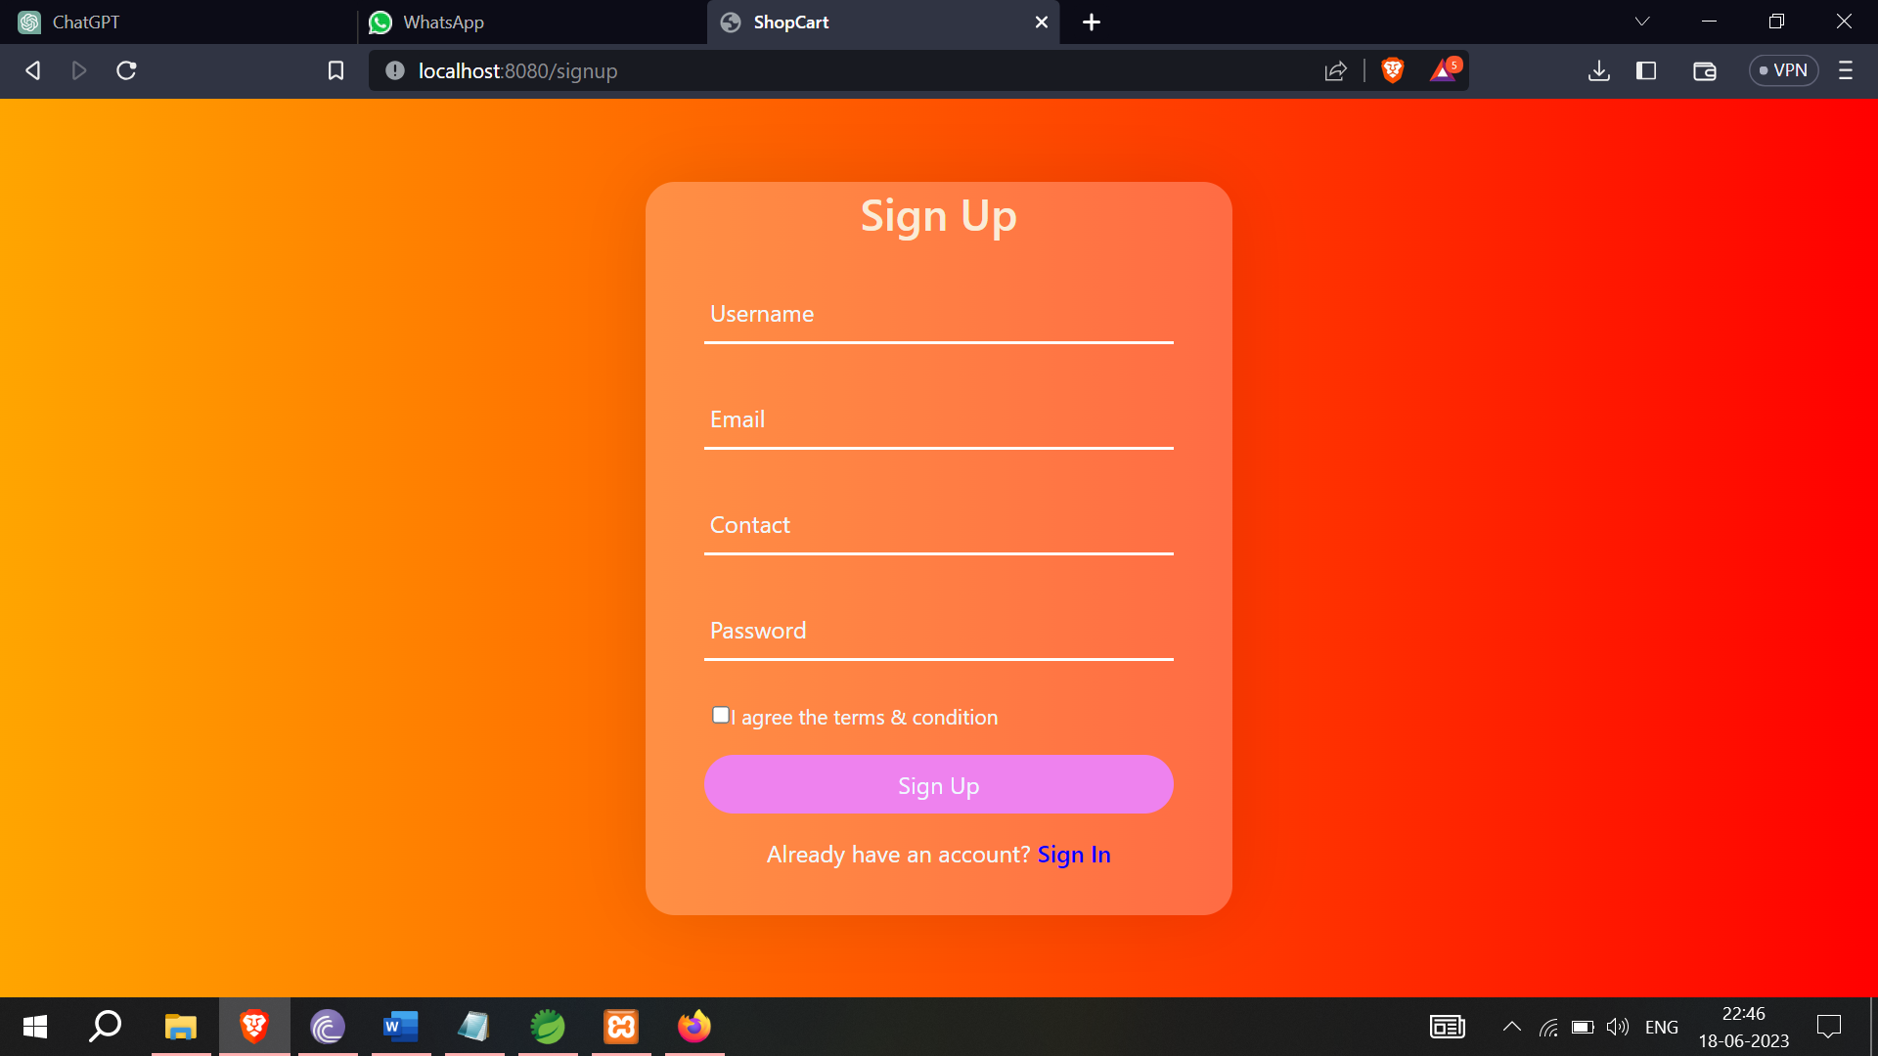

**Figure-7.1**(Sign In Form)

* + 1. **Login**

Once a user is registered, they can log in to the application using their credentials. The login process typically involves verifying the provided credentials and establishing a session for the user. Here's how you can implement login functionality with Spring Security:

Create a login form or API endpoint where users can enter their username and password.

Configure Spring Security to handle the authentication process, including user credential verification.

Upon successful authentication, generate a session for the user and associate it with their browser session.

Redirect the user to the appropriate page based on their role (ROLE_ADMIN or ROLE_USER).

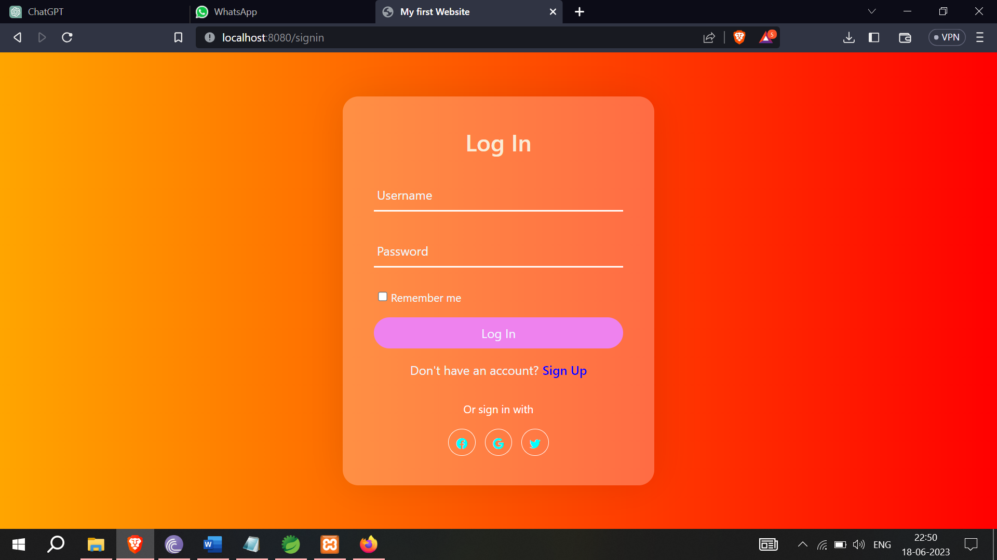

**Figure-7.2**(Log In Form)

* + 1. **Role-Based Authentication**

Role-based authentication allows you to control access to different parts of your application based on the user's role. In Spring Security, you can configure role-based authentication using annotations or XML-based configuration. Here's how you can set up role-based authentication:

Configure the security rules and access control in your application's configuration file (e.g., SecurityConfig.java or security.xml).

Define access rules based on roles, specifying which roles are allowed to access specific URLs or perform certain actions.

For example, you can restrict access to certain admin-only functionalities or pages to users with the ROLE_ADMIN role.

Handle access denial by redirecting the user to an appropriate page or showing an access denied message.

* 1. **Admin Section**

In an e-commerce site, the admin section is a crucial part that allows administrators or authorized personnel to manage and control various aspects of the website. The admin section typically provides functionalities for managing products, orders, customers, and other administrative tasks. Here's a detailed description of the admin section in an e-commerce site:

**Product Management:**

The admin section includes features to manage the products available on the e-commerce site. It allows administrators to add, edit, and delete products. The product management functionality may include features such as:

- Adding new products with details like name, description, price, images, categories, and inventory.

- Editing existing product information, such as updating prices, modifying descriptions, or changing product images.

- Setting up product categories or tags to organize products for easier navigation and searching.

- Managing product inventory, including tracking stock levels, restocking, and handling product variants (e.g., brand, colors).

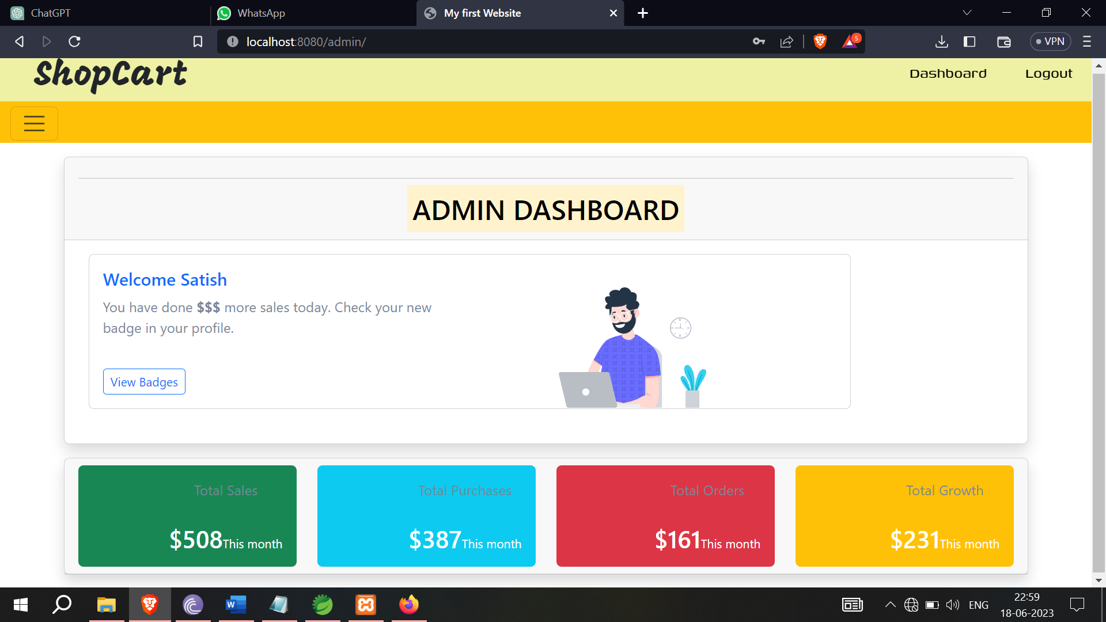

**Figure-7.3**(Admin Dashboard)

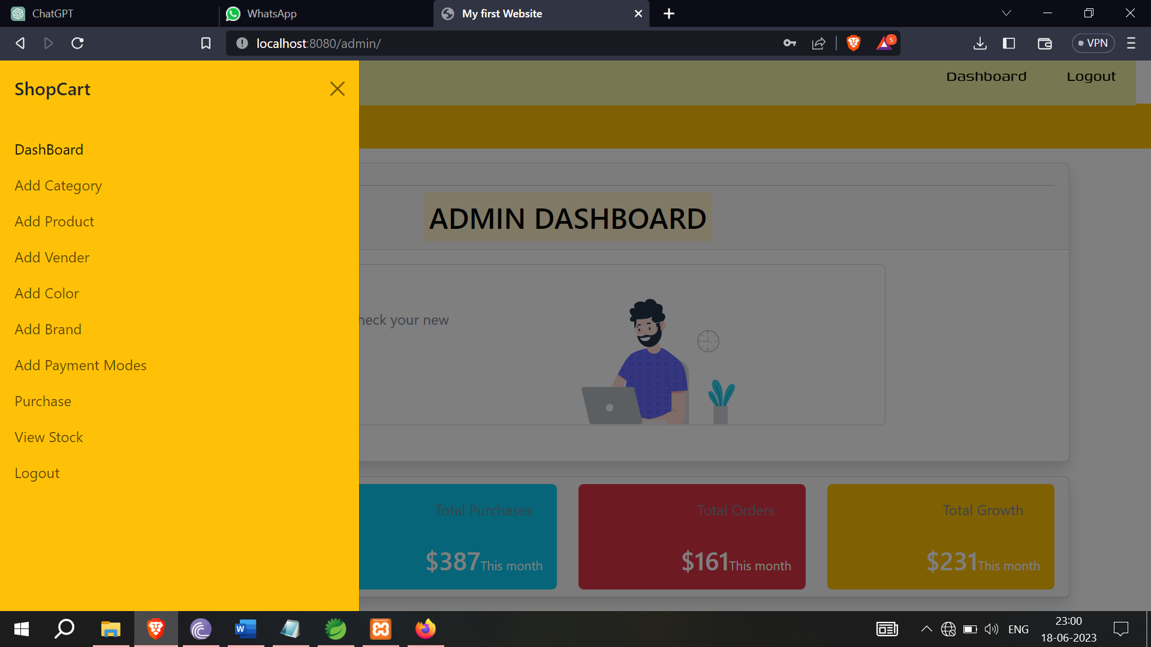

**Figure-7.4**(Admin Features)

* + 1. **Features of Admin Section**

1. **Category Management:**

The admin section allows administrators to add and manage product categories. Category management functionality includes:

- Creating new categories to organize products based on their types, such as electronics, clothing, home appliances, etc.

- Editing category details like name, description, and parent category (if applicable).

- Deleting categories that are no longer needed.

- Viewing and managing the hierarchy of categories to maintain a structured product catalog.

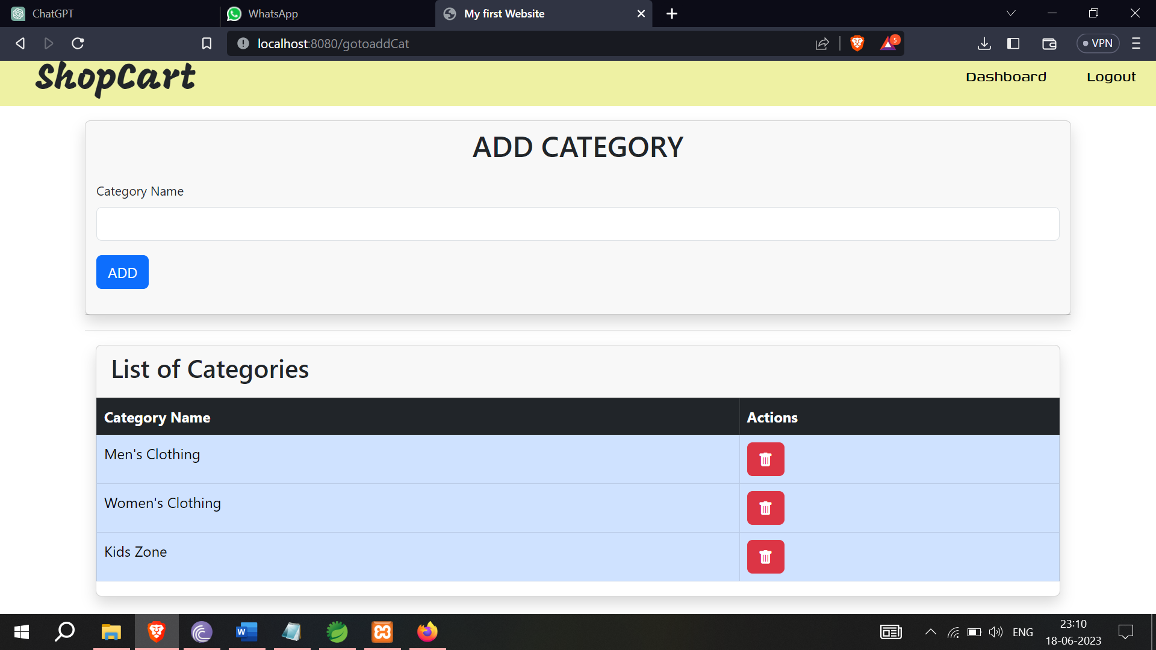

**Figure-7.5**(Add Category)

2. **Product Management:**

The admin section enables administrators to add, edit, and manage products within the selected categories. Product management functionality includes:

- Adding new products by providing details such as name, description, price, images, and SKU (stock keeping unit).

- Associating products with relevant categories for easy navigation and browsing.

- Editing product information, including updating prices, modifying descriptions, or changing product images.

- Assigning attributes to products, such as color, brand, vendor, and other custom attributes specific to your business.

- Defining product variants, such as different sizes or colors, and managing their stock availability.

- Managing product inventory, including tracking stock levels, restocking, and setting alerts for low stock.

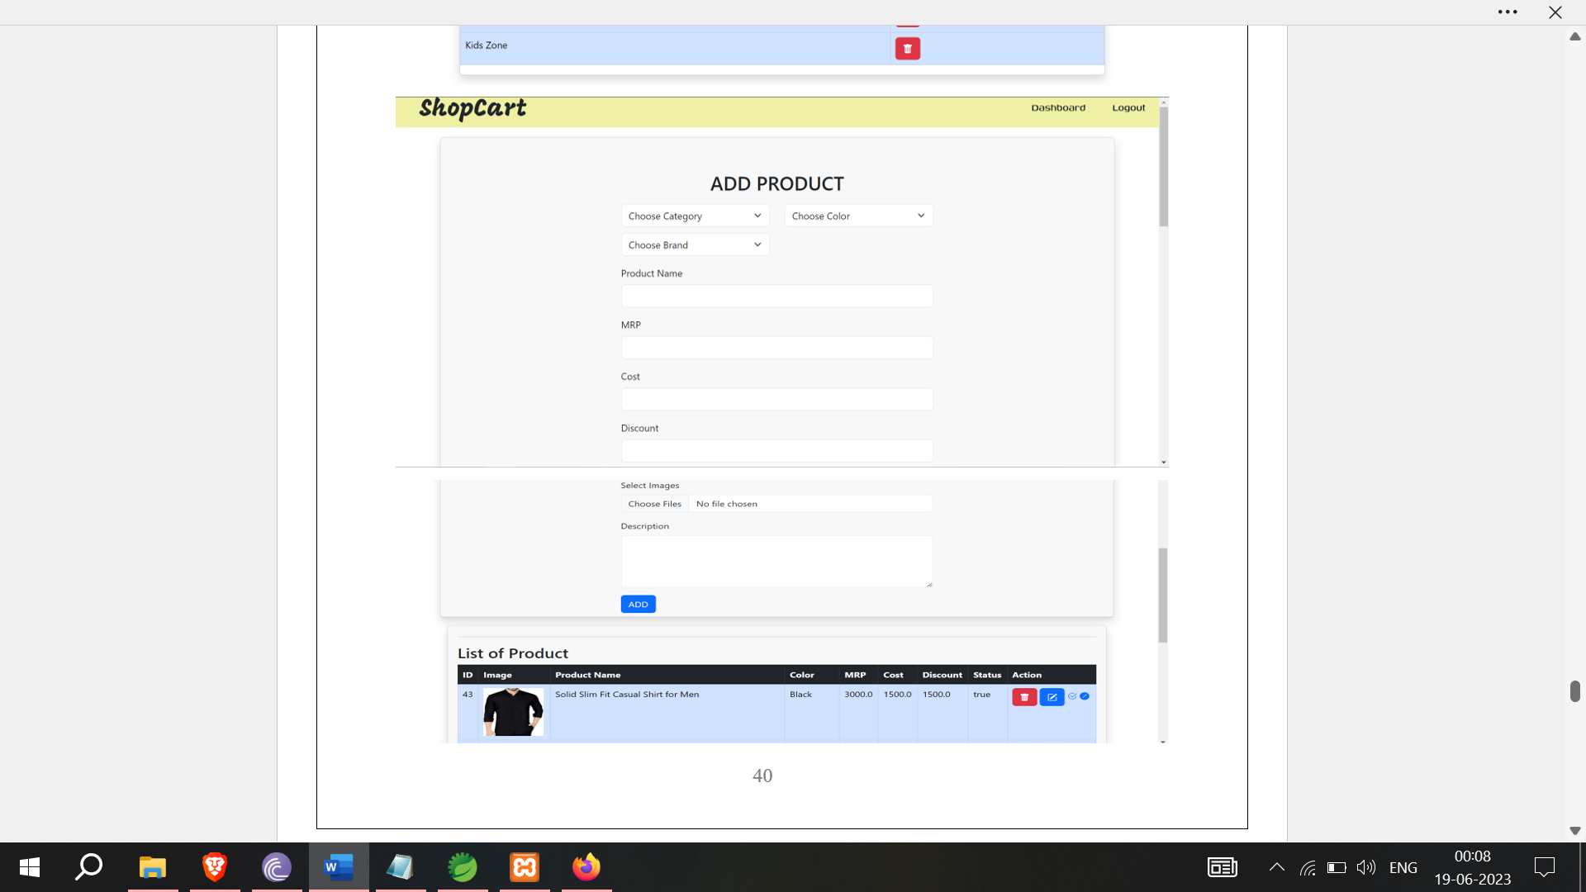

**Figure-7.6**(Add Product)

3. **Color, Brand, Vendor Management:**

The admin section includes features to manage colors, brands, and vendors associated with the products. This functionality allows administrators to:

- Add and manage colors that are available for products. This helps customers filter products by color preference.

- Add and manage brands to categorize products based on their manufacturers or brands.

- Add and manage vendors or suppliers who provide the products for sale on the e-commerce platform.

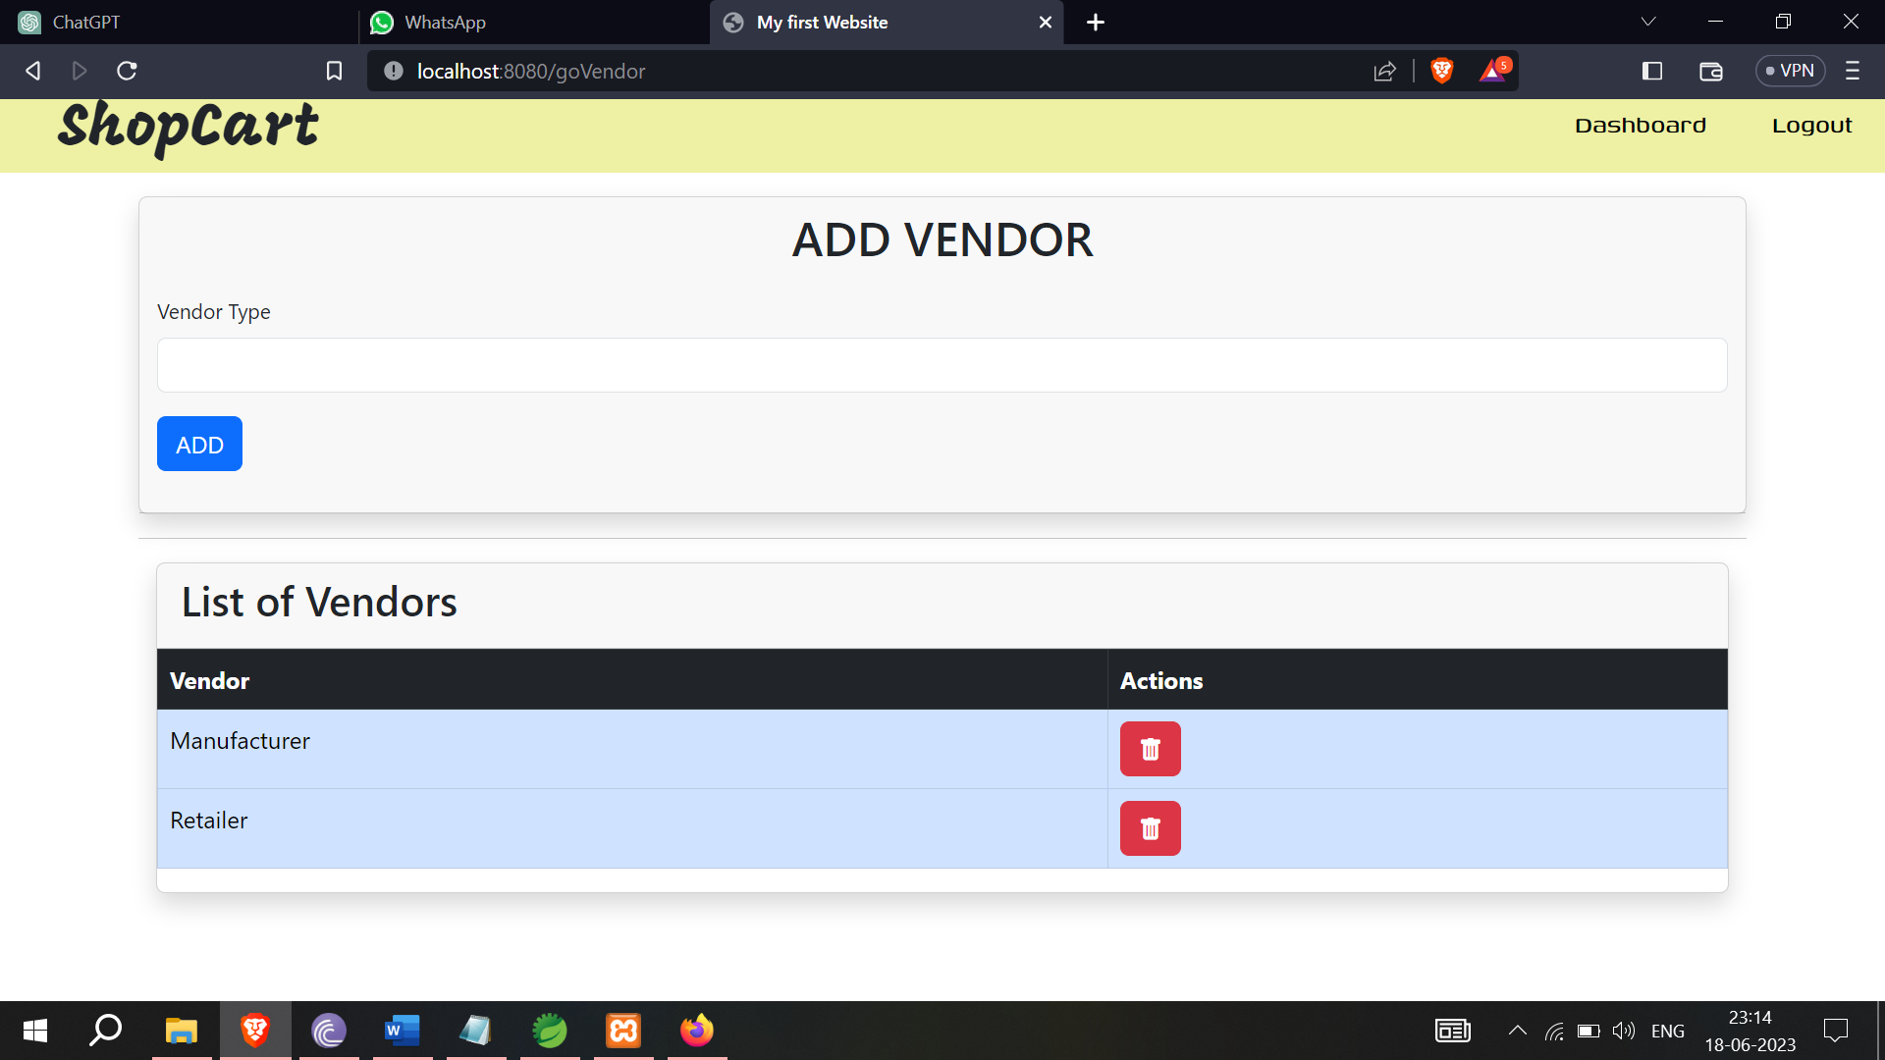

**Figure-7.7**(Add Vendor)

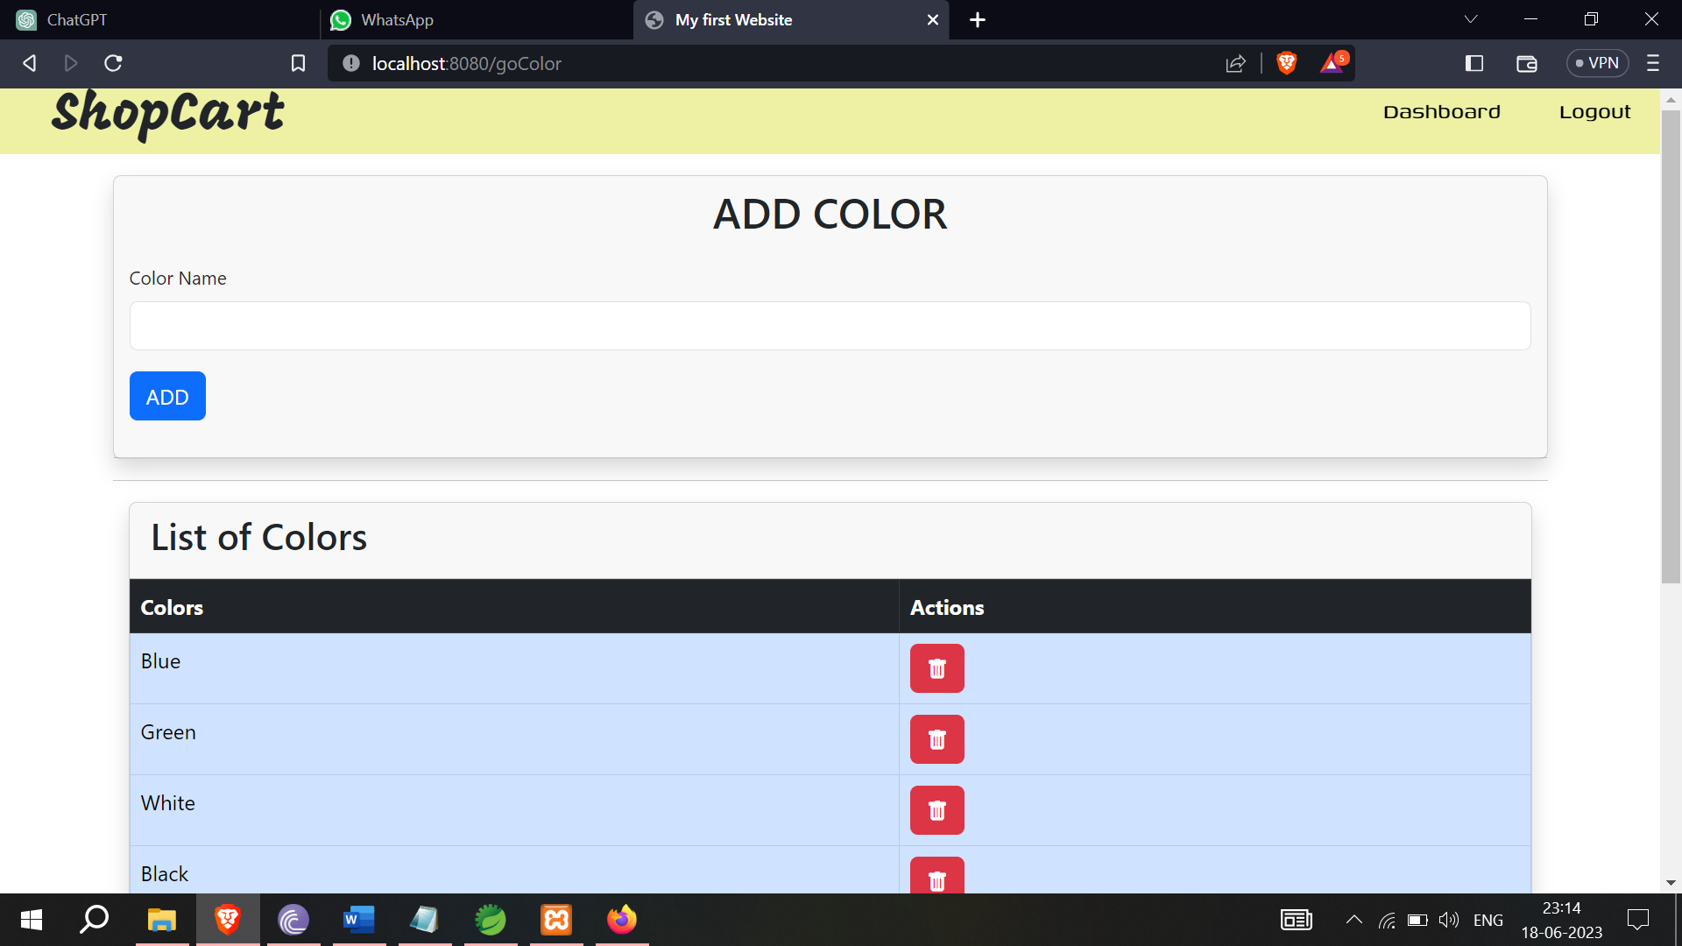

**Figure-7.8**(Add Color)

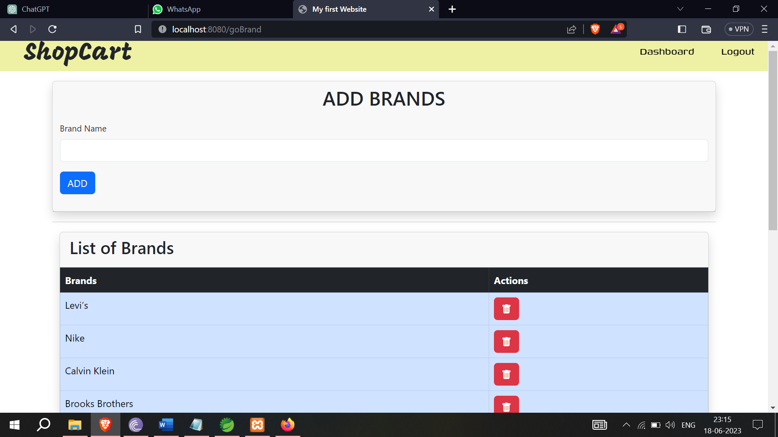

**Figure-7.9**(Add Brands)

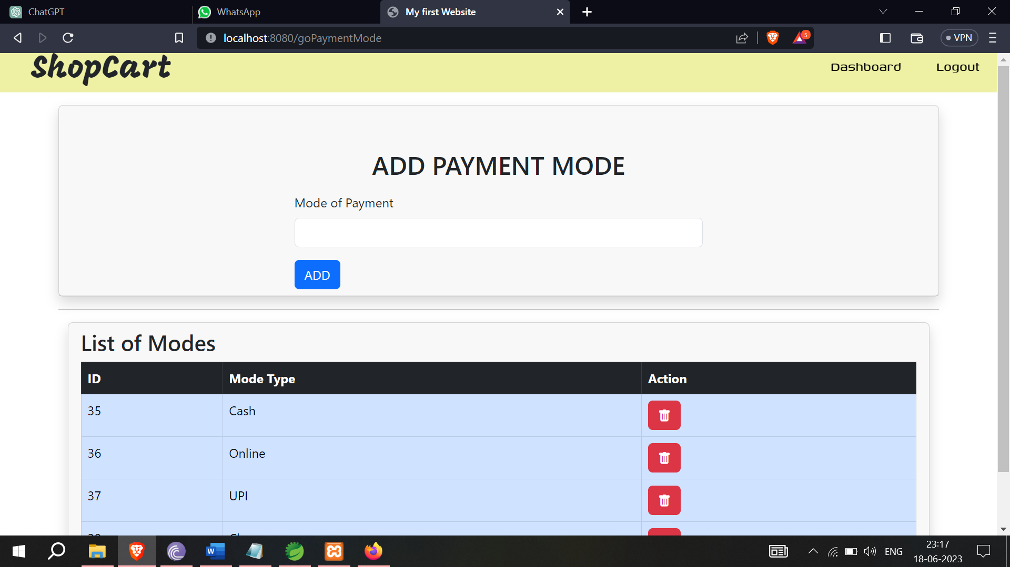

**Figure-7.10**(Add Payment Modes)

4. **Purchase and Product Details:**

The admin section provides options to enter purchase details and additional product information. This functionality includes:

- Tracking purchase details, such as the date of purchase, supplier information, and purchase price.

- Adding product-specific information that may vary depending on the type of product being sold (e.g., technical specifications for electronics, fabric details for clothing).

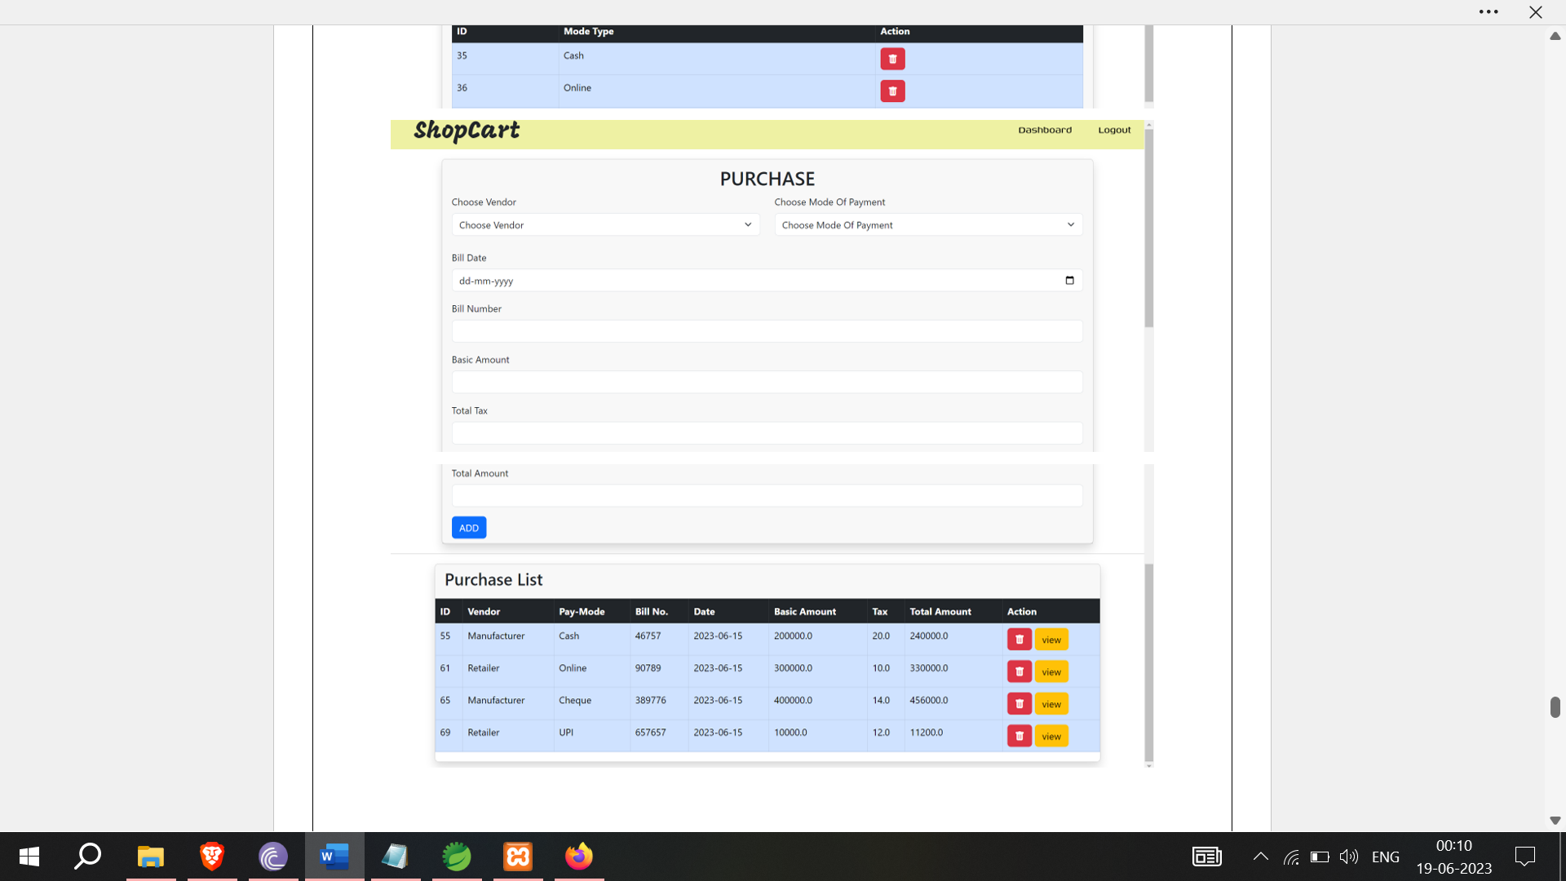

**Figure-7.11** (Purchase and Purchase List)

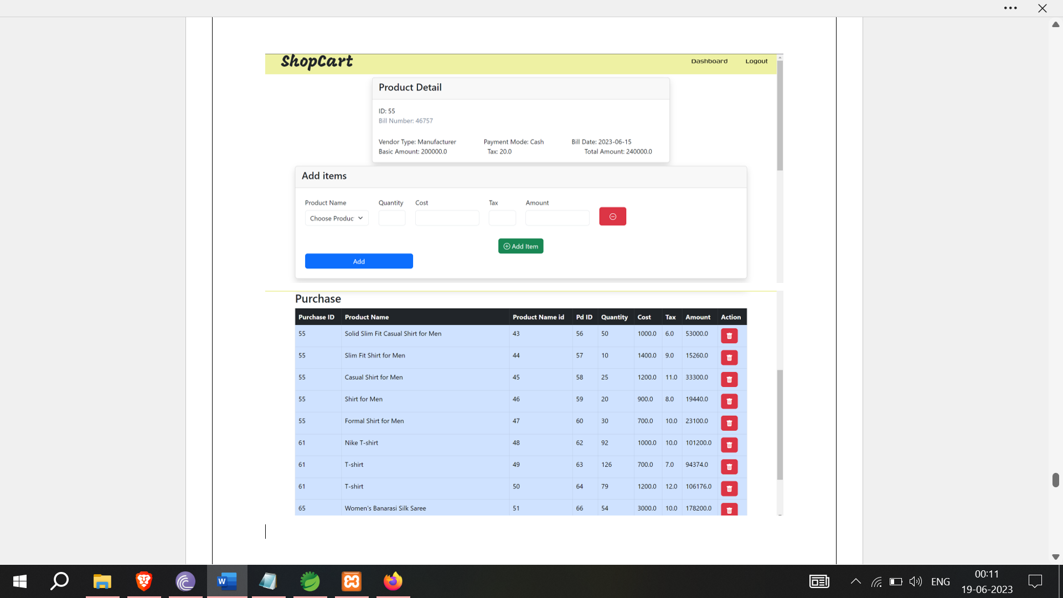

**Figure-7.12** ( Add Product Detail & Purchase Products list)

5. **Stock Detail Management:**

The admin section allows administrators to manage stock details for products. This functionality includes:

- Tracking stock levels and availability for each product.

- Updating stock quantities when new inventory arrives or when products are sold.

- Setting up low stock alerts to ensure timely restocking.

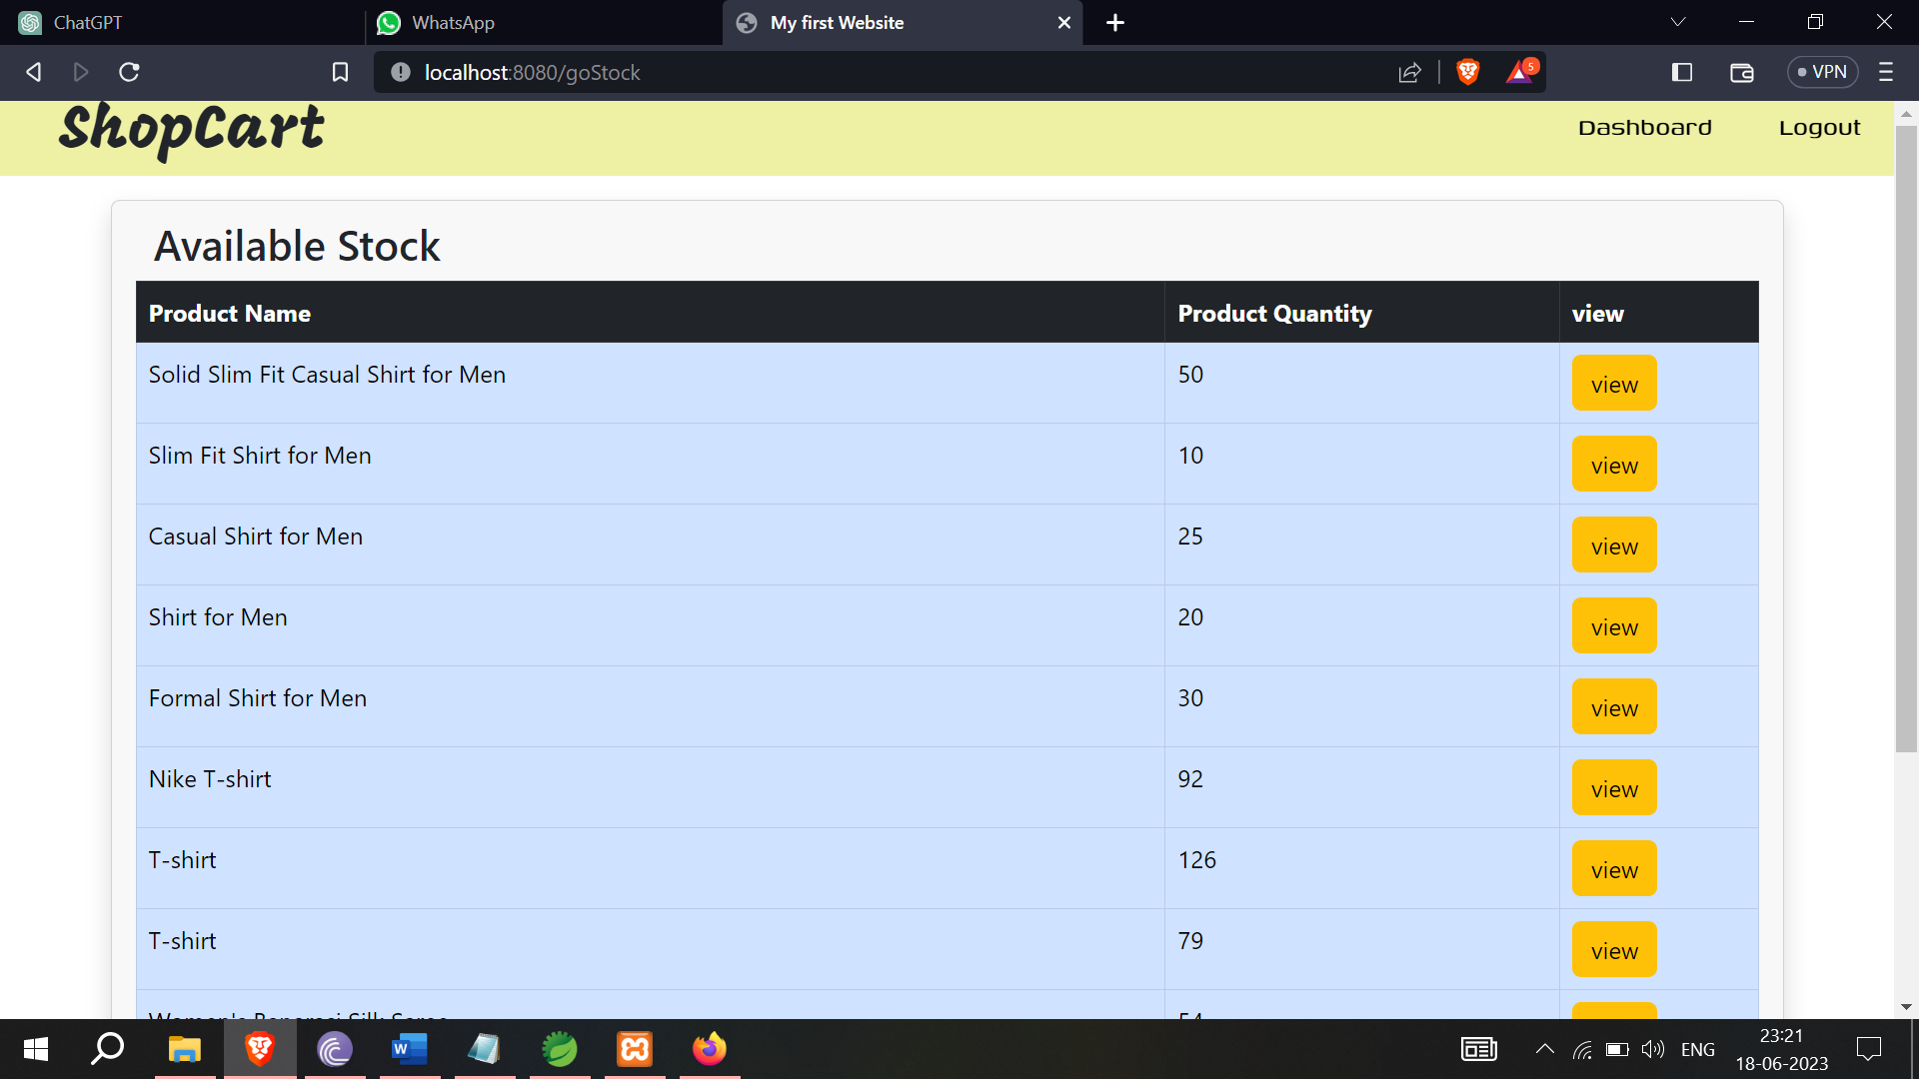

**Figure-7.13**(Stock List)

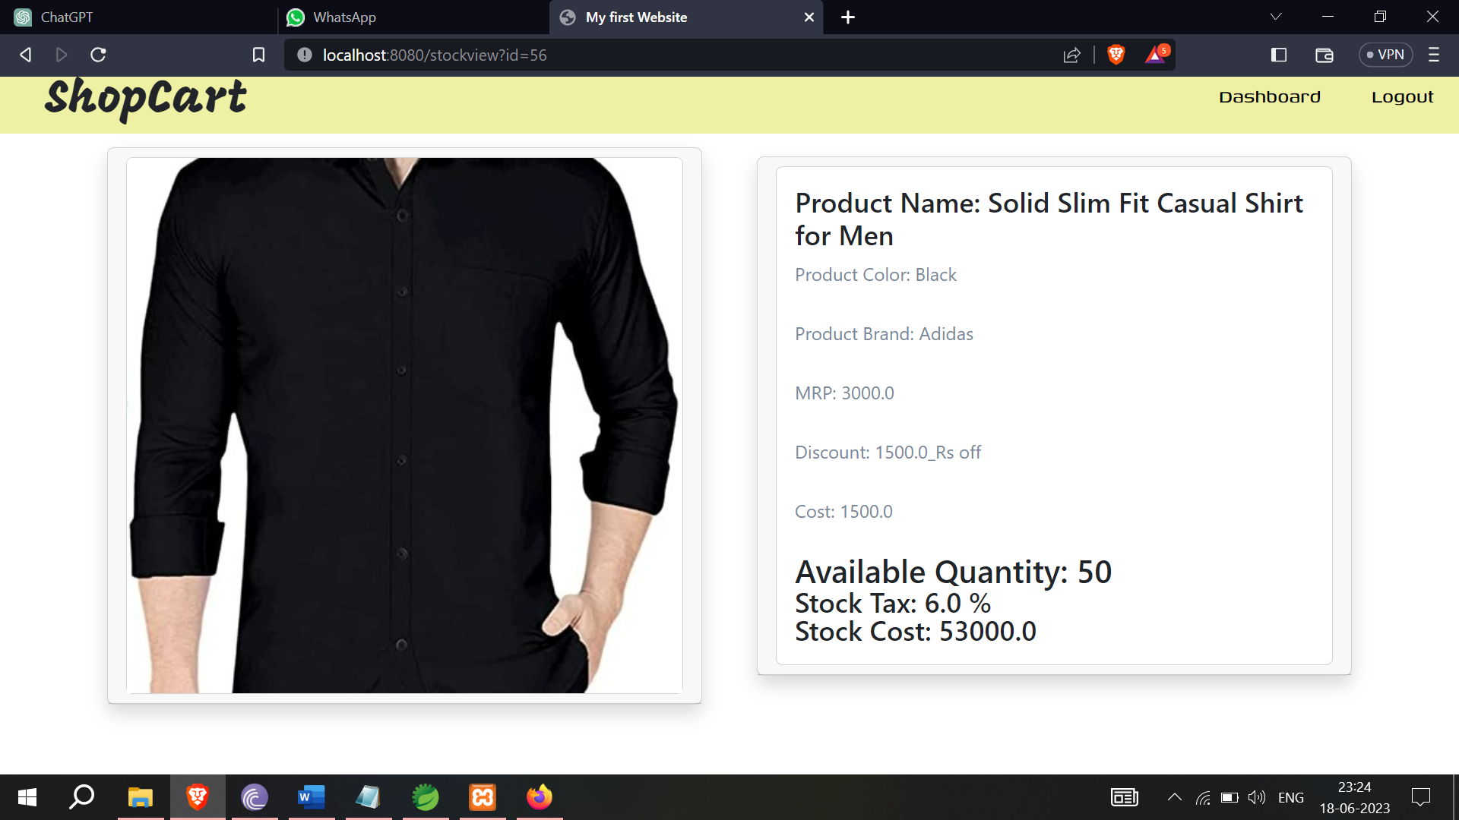

**Figure-7.14**(Stock Product View)

These features collectively provide administrators with comprehensive control over the e-commerce site's product catalog, including categories, product details, attributes, vendors, and stock management.

* 1. **Customer or User Section**

1. **Profile Page:**

The profile page allows users to manage their personal information and account settings. It includes features such as:

- Viewing and editing user profile details like name, email, contact information, and preferences.

- Updating account settings, such as password changes or email notification preferences.

- Managing user-specific settings, such as language preference or currency selection.

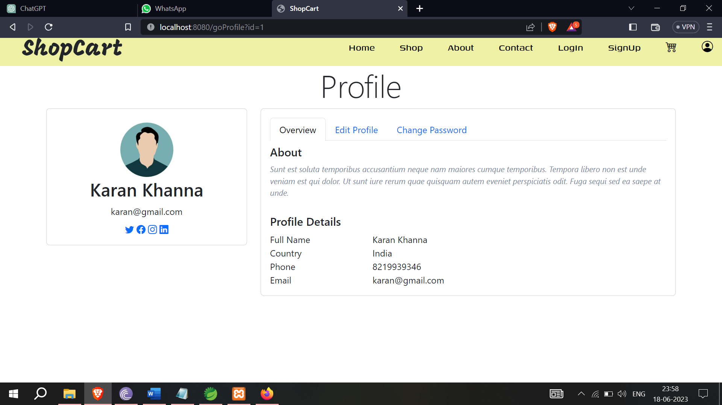

**Figure-7.15** (Customer’s Profile)

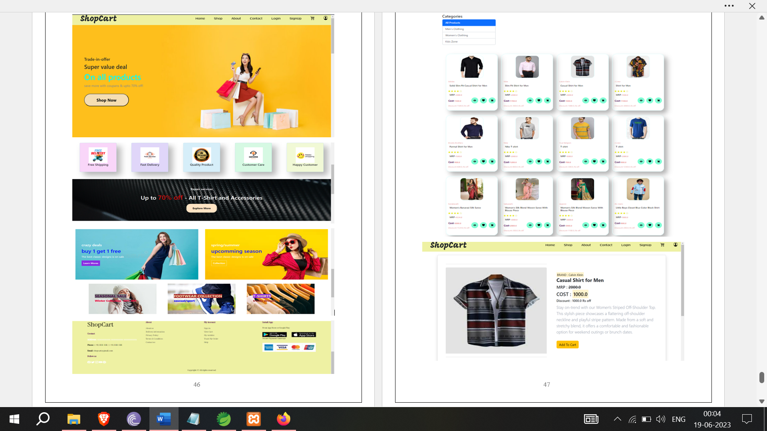

**Figure-7.16** (Website Home Page)

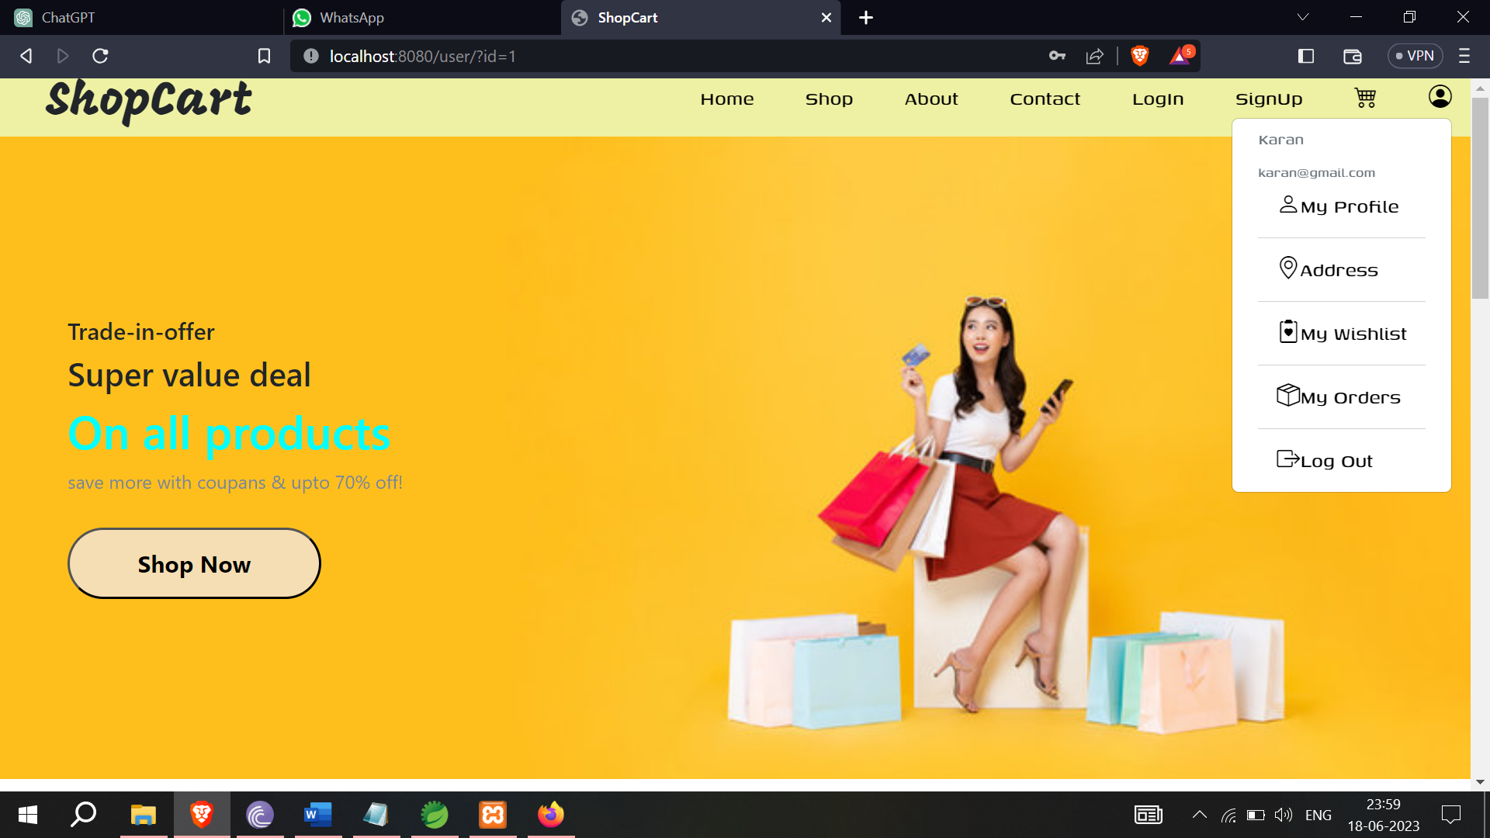

**Figure-7.17** (Customer Profile Features)

2. **Addresses Page:**

The addresses page enables users to manage their shipping and billing addresses. This functionality may include:

- Adding new addresses for shipping or billing purposes.

- Editing or deleting existing addresses.

- Setting a default address for convenience during the checkout process.

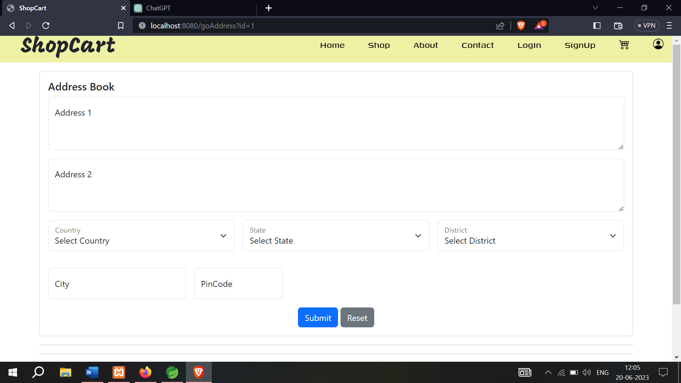

**Figure-7.18** (Address Page)

3. **Cart Page:**

The cart page displays the products that users have added to their shopping cart. The cart functionality includes:

- Showing a summary of the products, quantities, and prices in the user's cart.

- Allowing users to adjust the quantity of products or remove items from the cart.

- Calculating and displaying the total price, including any discounts or promotions.

- Providing a button to proceed to the checkout page for order placement.

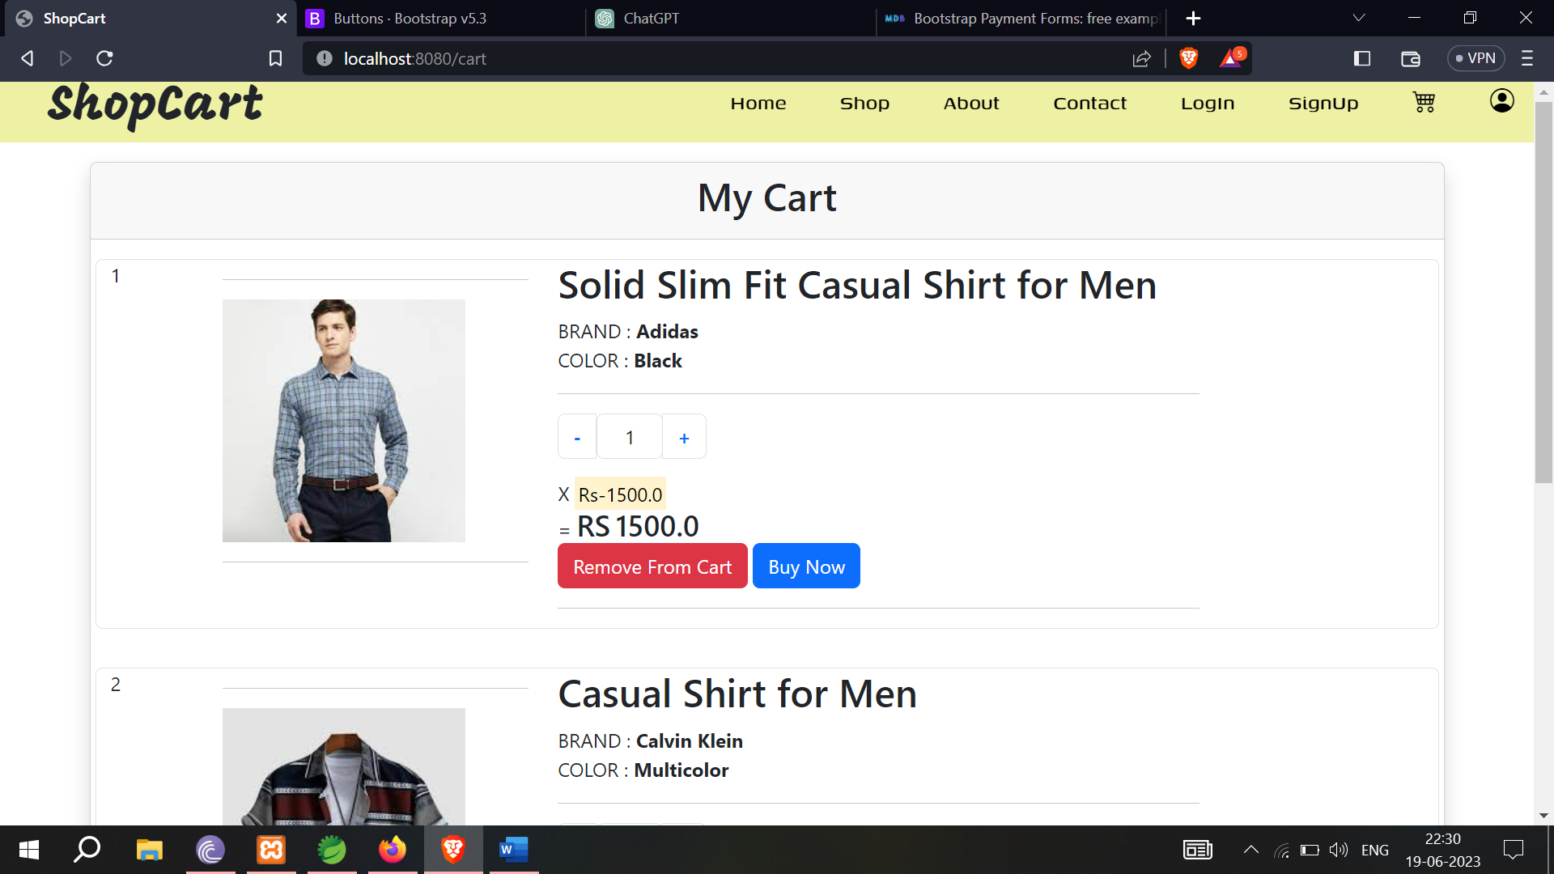

**Figure-7.19** (Website Cart)

4. **Wishlist Page:**

The wishlist page allows users to save products they are interested in for future reference. Wishlist functionality includes:

- Displaying a list of products that the user has added to their wishlist.

- Providing the ability to add or remove products from the wishlist.

- Allowing users to move wishlist items to the cart for immediate purchase.

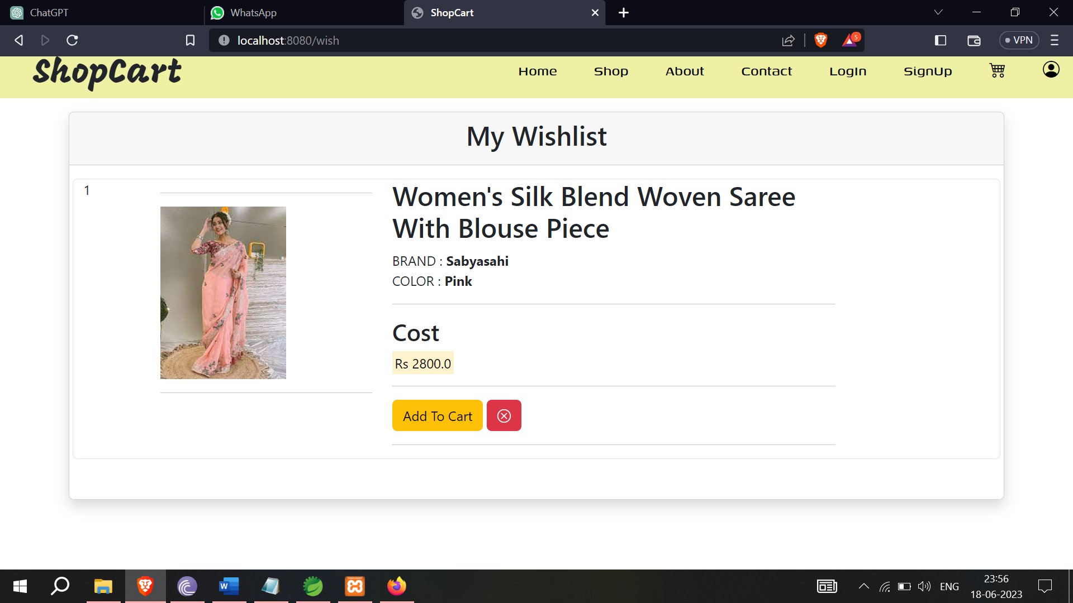

**Figure-7.20** (Wishlist)

5. **Shop Page:**

The shop page is where users can browse and search for products available on the e-commerce site. Shop page functionality includes:

- Displaying product categories or filters to help users narrow down their search.

- Listing products based on the selected category or search query.

- Showing product thumbnails, names, prices, and ratings.

- Allowing users to click on a product to view its detailed information.

- Providing options to add the product to the cart or wishlist directly from the shop page.

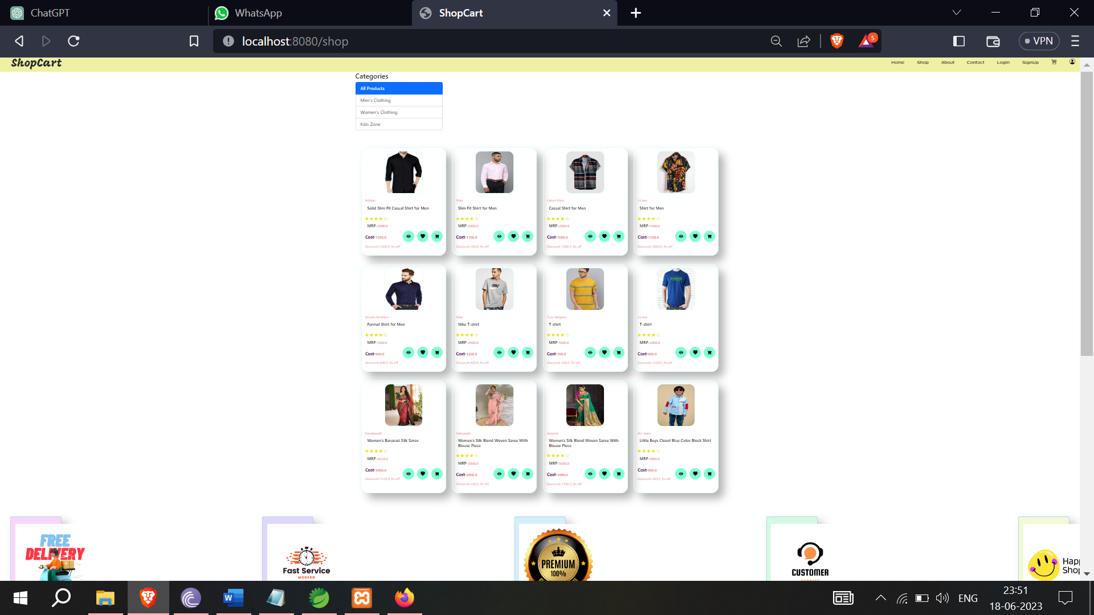

**Figure-7.21** (Website Shop)

6. **Order Page:**

The order page is a critical component of an e-commerce website or any online platform that facilitates the purchase of products or services.

The order page plays a vital role in facilitating seamless and secure transactions, enhancing the customer experience, and driving business growth. It serves as the final touchpoint in the buying process and can significantly influence customer satisfaction, loyalty, and business success.

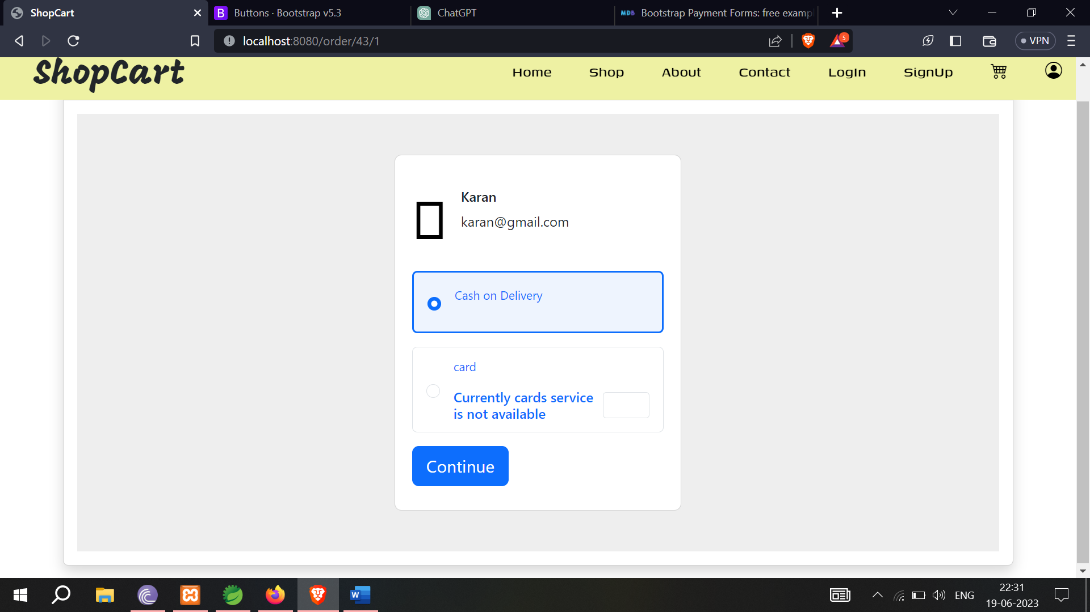

**Figure-7.22** (Customer’s Payment Option Page)

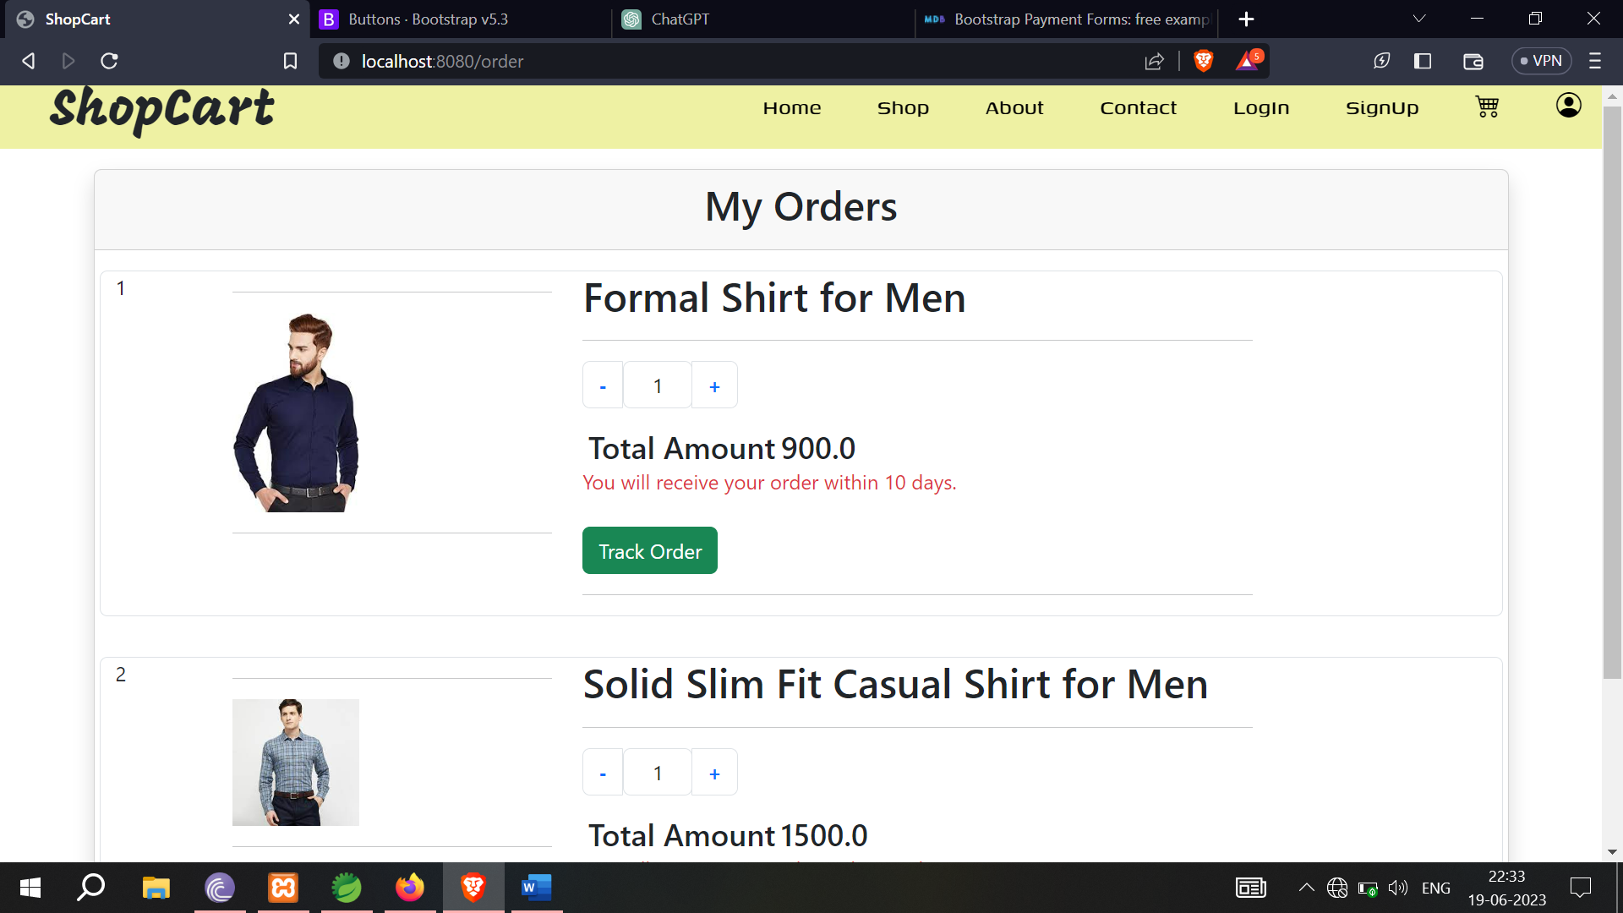

**Figure-7.23** (Customer’s Order Page)

7. **Product Detail Page:**

The product detail page provides comprehensive information about a specific product. Key features of the product detail page include:

- Displaying the product name, description, images, price, and other relevant details.

- Showing product variations (e.g., brand, color) and allowing users to select their preferred options.

- Providing a button to add the product to the cart and wishlist.

- Showing product reviews and ratings from other customers.

- Displaying related or recommended products for cross-selling or upselling.

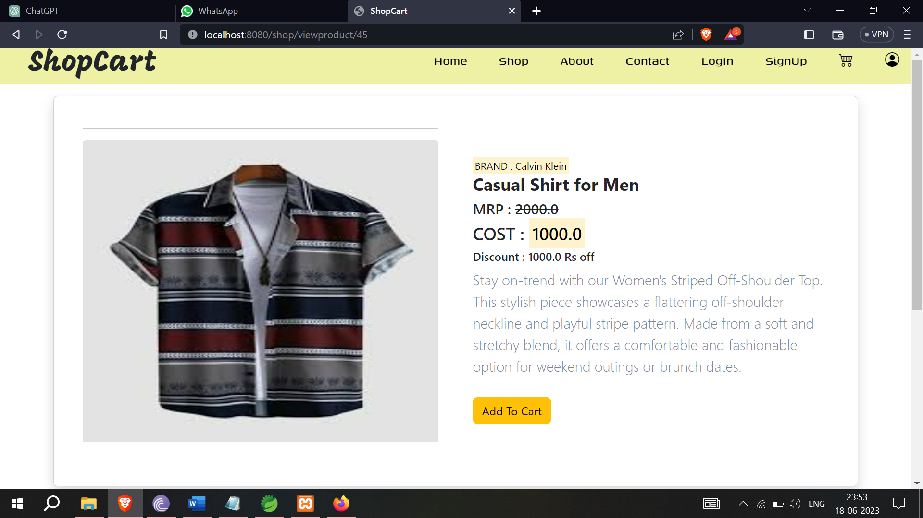

**Figure-7.24** (Product Detailed View)

* 1. **About Us**

The "About Us" page of an e-commerce site holds significant importance as it serves as a gateway for customers to connect with your brand on a deeper level. It provides an opportunity to establish trust, showcase your brand's unique identity, and communicate your mission and values. This page allows you to differentiate yourself from competitors, highlight the quality and selection of your products, and demonstrate your commitment to customer satisfaction. By crafting a compelling "About Us" page, you can inspire confidence in potential customers, foster brand loyalty, and create a memorable impression that encourages repeat visits and word-of-mouth recommendations. Ultimately, the "About Us" page is a powerful tool to humanize your e-commerce business and build meaningful relationships with your customers, leading to long-term success in the online marketplace.

The "About Us" page can contribute to your site's search engine optimization (SEO) efforts. By incorporating relevant keywords, unique content, and links to other pages on your site, you can improve your search engine rankings. This can lead to increased visibility and organic traffic to your e-commerce site.

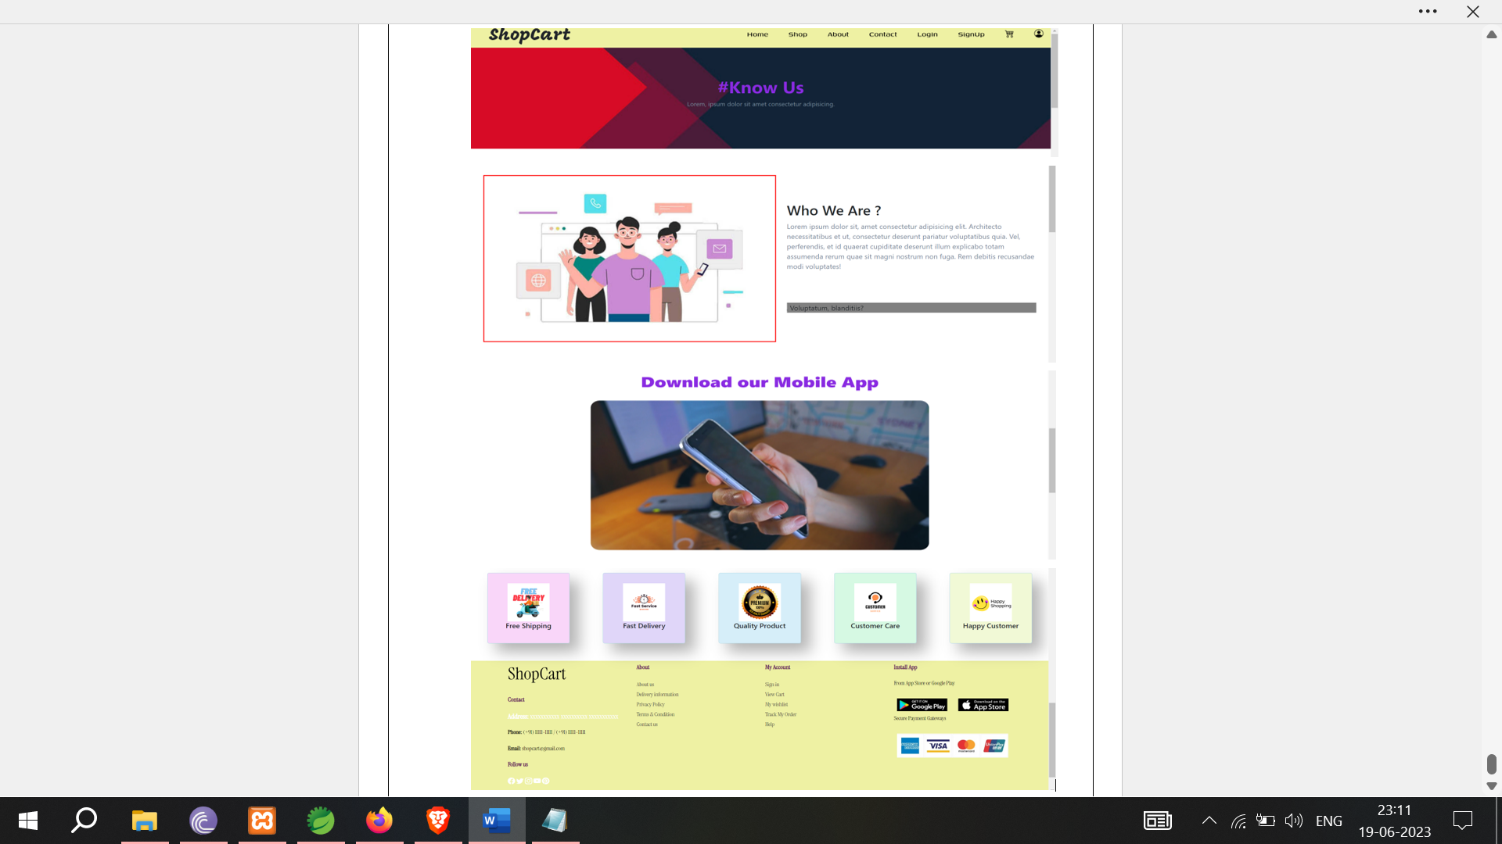

**Figure-7.25** (About Us Page)

* 1. **Contact Us**

The "Contact Us" page is of utmost importance for an e-commerce site as it serves as a direct line of communication between the business and its customers. Here are a couple of passages highlighting the significance of the "Contact Us" page

The "Contact Us" page holds immense importance in an e-commerce site as it serves as a crucial point of interaction between the business and its customers. This page provides a convenient and easily accessible means for customers to reach out with their inquiries, concerns, or feedback. By offering clear contact information such as email addresses, phone numbers, and social media links, you create a sense of transparency and accessibility, allowing customers to connect with your brand on a personal level. The "Contact Us" page not only helps resolve customer issues promptly but also builds trust and confidence in your business. It demonstrates that you value customer satisfaction and are willing to address their needs. Additionally, the "Contact Us" page can be utilized to provide information about customer support channels, operating hours, and frequently asked questions, further streamlining the customer experience. Ultimately, an effective "Contact Us" page plays a vital role in fostering positive customer relationships, enhancing customer loyalty, and ensuring a seamless shopping experience.

In the dynamic world of e-commerce, the "Contact Us" page acts as a lifeline, connecting businesses with their customers. This page provides a platform for customers to voice their concerns, seek clarification, or receive assistance, thus enabling businesses to deliver exceptional customer service. By including a well-crafted "Contact Us" form, businesses can gather valuable customer information and tailor their responses accordingly. Moreover, the "Contact Us" page is instrumental in building trust and credibility. When customers see that a business readily provides contact details, it instills a sense of reliability and professionalism. This page also serves as a gateway to potential business opportunities, as it allows for collaborations, partnership inquiries, or wholesale inquiries. By prioritizing the "Contact Us" page, businesses can nurture customer relationships, address concerns promptly, and leverage feedback to continuously improve their products and services. Ultimately, the "Contact Us" page is an indispensable component of any successful e-commerce site, facilitating effective communication, fostering trust, and driving customer satisfaction.

The "Contact Us" page of ShopCart is designed to provide users with multiple ways to get in touch with the business and ensure effective communication. It consists of several sections that serve different purposes:

1. Contact Page Banner: The banner sets the tone by inviting users to engage with the business and leave a message. It conveys the message that the business values customer feedback and is eager to hear from them.

2. Contact Details: This section provides essential contact information, including the head office address, email address, phone numbers, and operating hours. Users can choose the preferred method to reach out to the business based on their needs and convenience.

3. Location Map: The inclusion of an embedded Google Maps view allows users to visually locate the business's physical address. It helps users who prefer in-person visits or need directions to the office.

4. Contact Form: The contact form provides a convenient way for users to send messages directly to the business. It includes fields for the user's name, email, subject, and a larger text area for composing their message. The form allows users to provide detailed information and ensures that their inquiries or concerns are properly conveyed.

5. Key Personnel: The section featuring images and information about key personnel, such as senior marketing managers, adds a personal touch to the "Contact Us" page. It helps users feel more connected and provides them with specific contacts they can reach out to for assistance or inquiries.

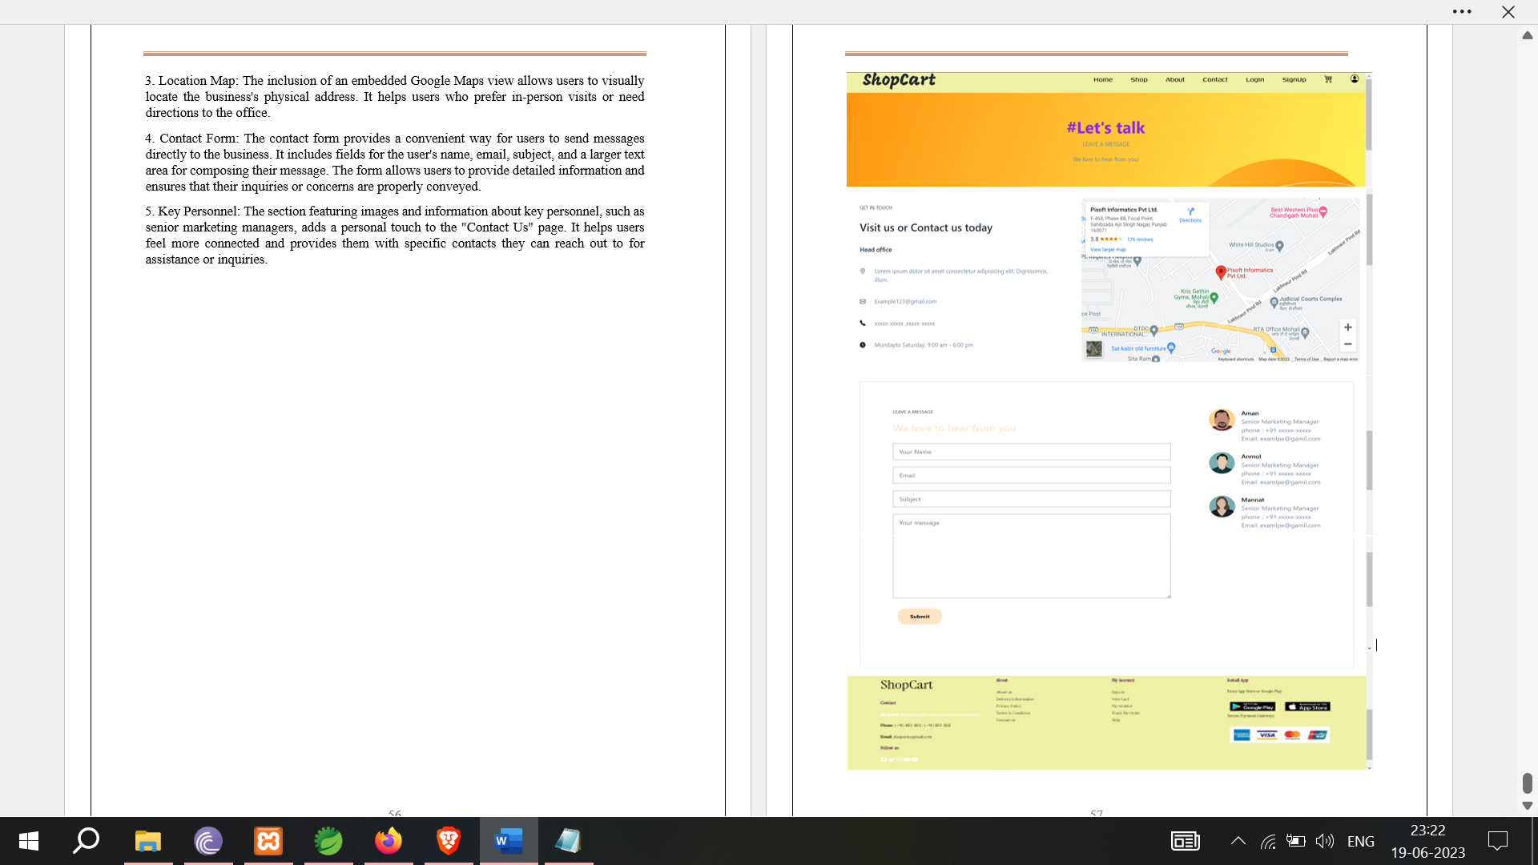

**Figure-7.26** (Contact Us Page)

**Chapter-8**

**SPRING BOOT PROJECT**

* 1. **Spring Boot Architecture**

Spring Boot is a module of the Spring Framework. It is used to create stand-alone, production-grade Spring Based Applications with minimum efforts. It is developed on top of the core Spring Framework.

Spring Boot follows a layered architecture in which each layer communicates with the layer directly below or above (hierarchical structure) it.

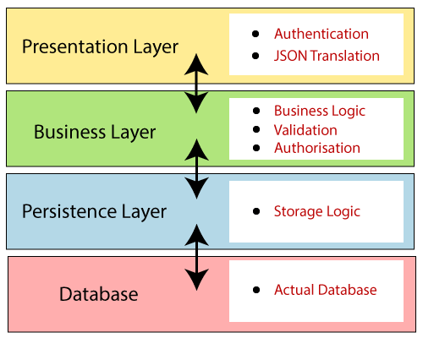Before understanding the Spring Boot Architecture, we must know the different layers and classes present in it. There are four layers in Spring Boot are as follows:

* Presentation Layer
* Business Layer
* Persistence Layer
* Database Layer

**Figure-8.1** (Spring Boot Architecture)

**Presentation Layer:** The presentation layer handles the HTTP requests, translates the JSON parameter to object, and authenticates the request and transfer it to the business layer. In short, it consists of **views** i.e., frontend part.

**Business Layer:** The business layer handles all the **business logic**. It consists of service classes and uses services provided by data access layers. It also performs **authorization** and **validation**.

**Persistence Layer:** The persistence layer contains all the **storage logic** and translates business objects from and to database rows.

**Database Layer:** In the database layer, **CRUD** (create, retrieve, update, delete) operations are performed.

* 1. **Spring Boot Flow Architecture**



**Figure-8.2** (Spring Boot Flow Architecture)

* Now we have validator classes, view classes, and utility classes.
* Spring Boot uses all the modules of Spring-like Spring MVC, Spring Data, etc. The architecture of Spring Boot is the same as the architecture of Spring MVC, except one thing: there is no need for **DAO** and **DAOImpl** classes in Spring boot.
* Creates a data access layer and performs CRUD operation.
* The client makes the HTTP requests (PUT or GET).
* The request goes to the controller, and the controller maps that request and handles it. After that, it calls the service logic if required.
* In the service layer, all the business logic performs. It performs the logic on the data that is mapped to JPA with model classes.
* A JSP page is returned to the user if no error occurred.
  1. **Spring Initializr**

**Spring Initializr** is a **web-based tool** provided by the Pivotal Web Service. With the help of **Spring Initializr**, we can easily generate the structure of the **Spring Boot Project**. It offers extensible API for creating JVM-based projects.

It also provides various options for the project that are expressed in a metadata model. The metadata model allows us to configure the list of dependencies supported by JVM and platform versions, etc. It serves its metadata in a well-known that provides necessary assistance to third-party clients.

The following image shows the Spring Initializr UI:

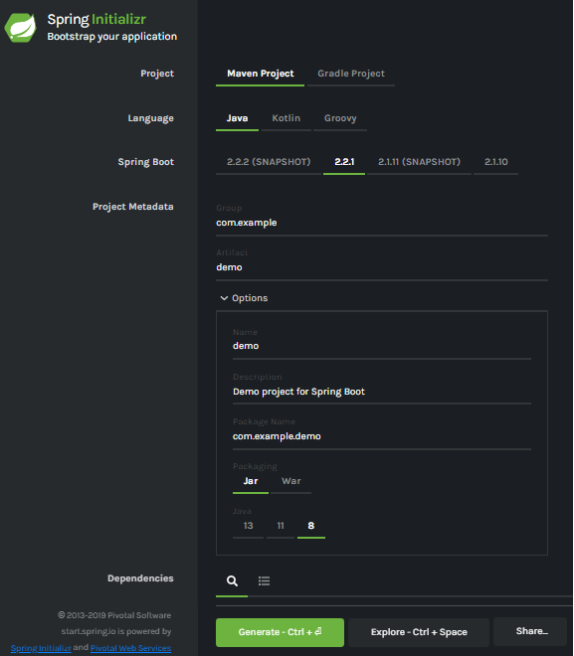

**Figure-8.3** (Spring **Initializr UI**)

* 1. **Generating a Project**

Before creating a project, we must be friendly with UI. Spring Initializr UI has the following labels:

* **Project:** It defines the **kind** of project. We can create either **Maven Project** or **Gradle Project**. We will create a **Maven Project** throughout the tutorial.
* **Language:** Spring Initializr provides the choice among three languages **Java, Kotlin,** and **Groovy**. Java is by default selected.
* **Spring Boot:** We can select the Spring Boot **version**. The latest version is **2.2.2**.
* **Project Metadata:** It contains information related to the project, such as **Group**, Artifact, etc. Group denotes the **package** name; **Artifact** denotes the **Application** name. The default Group name is **com.example**, and the default Artifact name is **demo**.
* **Dependencies:** Dependencies are the collection of artifacts that we can add to our project.

There is another **Options** section that contains the following fields:

* **Name:** It is the same as **Artifact**.
* **Description:** In the description field, we can write a **description** of the project.
* **Package Name:** It is also similar to the **Group** name.
* **Packaging:** We can select the **packing** of the project. We can choose either **Jar** or **War**.
* **Java:** We can select the **JVM** version which we want to use. We will use **Java 8** version throughout the tutorial.

There is a **Generate** button. When we click on the button, it starts packing the project and downloads the **Jar** or **War** file, which we have selected.

* 1. **Creating a Spring Boot Project**

Following are the steps to create a simple Spring Boot Project.

**Step 1:** Open the Spring initializr .

**Step-2:** Provide the **Group** and **Artifact** name. We have provided Group name **com.javatpoint** and Artifact **spring-boot-example**.

**Step 3:** Now click on the **Generate** button.

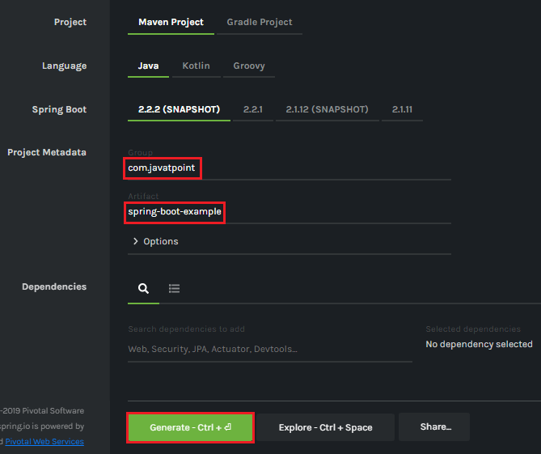

**Figure-8.4** (Spring **Initializr project generation**)

When we click on the Generate button, it starts packing the project in a **.rar** file and downloads the project.

**Step 4:** Extract the **RAR** file.

**Step 5:** **Import** the folder.

File -> Import -> Existing Maven Project -> Next -> Browse -> Select the project -> Finish

It takes some time to import the project. When the project imports successfully, we can see the project directory in the **Package Explorer**. The following image shows the project directory:

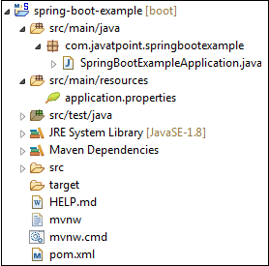

**Figure-8.5** (Project Structure)

**SpringBootExampleApplication.java**

**package** com.javatpoint.springbootexample;

**import** org.springframework.boot.SpringApplication;

**import** org.springframework.boot.autoconfigure.SpringBootApplication;

@SpringBootApplication

**public** **class** SpringBootExampleApplication

{

**public** **static** **void** main(String[] args)

{

SpringApplication.run(SpringBootExampleApplication.**class**, args);

}

}

**pom.xml**

**<?xml** version="1.0" encoding="UTF-8"**?>**

**<project** xmlns="http://maven.apache.org/POM/4.0.0" xmlns:xsi=http://www.w3.org/2001/XMLSchema-instance xsi:schemaLocation="http://maven.apache.org/POM/4.0.0 https://maven.apache.org/xsd/maven-4.0.0.xsd"**>**

**<modelVersion>**4.0.0**</modelVersion>**

**<parent>**

**<groupId>**org.springframework.boot**</groupId>**

**<artifactId>**spring-boot-starter-parent**</artifactId>**

**<version>**2.2.2.BUILD-SNAPSHOT**</version>**

**<relativePath/>** <!-- lookup parent from repository -->

**</parent>**

**<groupId>**com.javatpoint**</groupId>**

**<artifactId>**spring-boot-example**</artifactId>**

**<version>**0.0.1-SNAPSHOT**</version>**

**<name>**spring-boot-example**</name>**

**<description>**Demo project for Spring Boot**</description>**

**<properties>**

**<java.version>**1.8**</java.version>**

**</properties>**

**<dependencies>**

**<dependency>**

**<groupId>**org.springframework.boot**</groupId>**

**<artifactId>**spring-boot-starter**</artifactId>**

**</dependency>**

**<dependency>**

**<groupId>**org.springframework.boot**</groupId>**

**<artifactId>**spring-boot-starter-test**</artifactId>**

**<scope>**test**</scope>**

**<exclusions>**

**<exclusion>**

**<groupId>**org.junit.vintage**</groupId>**

**<artifactId>**junit-vintage-engine**</artifactId>**

**</exclusion>**

**</exclusions>**

**</dependency>**

**</dependencies>**

**<build>**

**<plugins>**

**<plugin>**

**<groupId>**org.springframework.boot**</groupId>**

**<artifactId>**spring-boot-maven-plugin**</artifactId>**

**</plugin>**

**</plugins>**

**</build>**

**<repositories>**

**<repository>**

**<id>**spring-milestones**</id>**

**<name>**Spring Milestones**</name>**

**<url>**https://repo.spring.io/milestone**</url>**

**</repository>**

**<repository>**

**<id>**spring-snapshots**</id>**

**<name>**Spring Snapshots**</name>**

**<url>**https://repo.spring.io/snapshot**</url>**

**<snapshots>**

**<enabled>**true**</enabled>**

**</snapshots>**

**</repository>**

**</repositories>**

**<pluginRepositories>**

**<pluginRepository>**

**<id>**spring-milestones**</id>**

**<name>**Spring Milestones**</name>**

**<url>**https://repo.spring.io/milestone**</url>**

**</pluginRepository>**

**<pluginRepository>**

**<id>**spring-snapshots**</id>**

**<name>**Spring Snapshots**</name>**

**<url>**https://repo.spring.io/snapshot**</url>**

**<snapshots>**

**<enabled>**true**</enabled>**

**</snapshots>**

**</pluginRepository>**

**</pluginRepositories>**

**</project>**

**Step 6:** Run the **SpringBootExampleApplication.java** file.

Right-click on the file -> Run As -> Java Applications

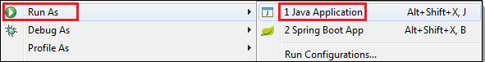

**Figure-8.6** (Run As-Java Application)

The following image shows the application runs successfully.

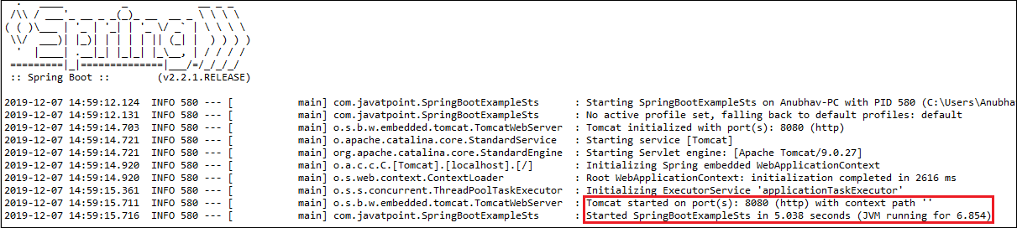

**Figure-8.7** (Spring Project Started)

* 1. **Spring Boot Application Property**

Spring Boot Framework comes with a built-in mechanism for application configuration using a file called **application.properties**. It is located inside the **src/main/resources** folder, as shown in the following figure.

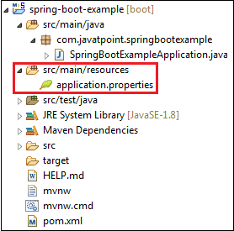

**Figure-8.8** (application.Propertiesfile)

Spring Boot provides various properties that can be configured in the **application.properties**file. The properties have default values. We can set a property(s) for the Spring Boot application. Spring Boot also allows us to define our own property if required.

The application.properties file allows us to run an application in a **different environment.**In short, we can use the application.properties file to:

* Configure the Spring Boot framework
* define our application custom configuration properties
  1. **Spring Boot Project-Code & Folder Structure**

While working on projects, it is very important to have proper folder structure and files. This is very important and we should do this in very initial phase of project. In this blog, will explain you the best standard practice and files for spring boot project. Learn how to integrate standard ways and practices for making your project efficient and developer friendly. Proper managing spring boot project will help all developers to follow standard practice.

In spring boot, there are different ways to structured the project. Mainly there are different ways for optimizing the project to work in efficient way. We can create folder layout in two different ways:

**1. Structure Layout by Features**

com

+- packagename

+- projectname

+- Application.java

|

+- User

| +- User.java

| +- UserController.java

| +- UserService.java

| +- UserRepository.java

|

+- order

+- Order.java

+- OrderController.java

+- OrderService.java

+- OrderRepository.java

**2. Structure Layout by Layer**

com

+- packagename

+- projectname

+- Application.java

|

+- models

| +- User.java

| +- Order.java

|

+- controllers

| +- OrderController.java

| +- UserController.java

|

+- services

| +- UserService.java

| +- OrderService.java

|

+- repositories

| +- UserRepository.java

| +- OrderRepository.java

|

+- configs

|

+- utils

In personally follow, Structure by Layout, which is best structure in my opinion. Some description regarding the folders

1. models – as name, we can keep models/domain
2. controllers – for keeping all controllers
3. services – for all services
4. repositories – keep all repositories
5. configs – configurations like WebAppSercurity.java
6. utils – feature specifics

**Structure for Resource / Template / Static files in Spring Boot**

Now we have created a structured folders for java code, it time for resource folders, where we keep our templates and static files. By default, you get templates and static folder in resources. In static you can create different assets folders and in template different sections like frontend and admin or backend. In templates, if you are using thymeleaf dependency, then you can keep fragments folder, where you keep parts of htmls.

├── java (....)

└── resources

├── application.properties

├── static

│   └── assets

│   ├── admin

│   └── frontend

└── templates

├── admin

│   ├── dashboard.html

│   └── fragments

└── frontend

├── 403.html

├── about-us.html

├── fragments

└── homepage.html

**Chapter-9**

**THYMELEAF**

* 1. **Introduction**

Thymeleaf is a popular Java-based server-side template engine for web applications. It is designed to be used in the context of the Java Spring Framework, although it can also be used as a standalone templating engine.

Thymeleaf aims to bring a natural and elegant way of writing templates by allowing developers to create HTML pages with embedded expressions and dynamic content. It follows a "natural templates" philosophy, which means that the templates should be readable and understandable even by people who are not familiar with the underlying technology.

Key features of Thymeleaf include:

1. **Expression Language** : Thymeleaf uses its own expression language (Thymeleaf Standard Expression Language or "Thymeleaf-EL") to evaluate expressions and perform dynamic operations within templates. The expression language allows developers to access and manipulate data from the model or context in which the template is rendered.

2. **HTML5 Compliance** : Thymeleaf is designed to be compatible with HTML5, which means that you can use all the standard HTML tags, attributes, and syntax in your templates. Thymeleaf-specific attributes are prefixed with "th:".

3. **Template Layouts** : Thymeleaf provides layout capabilities, allowing you to define reusable template fragments that can be included and reused across multiple pages. This helps in maintaining consistent page structure and reducing code duplication.

4. **Internationalization and Localization** : Thymeleaf provides built-in support for internationalization and localization, allowing you to easily create multilingual templates and handle language-specific content.

5. **Integration with Spring** : Thymeleaf is tightly integrated with the Spring Framework and is the recommended template engine for Spring-based applications. It supports various Spring features, such as accessing Spring beans in expressions, handling form binding and validation, and more.

To use Thymeleaf, you need to include the Thymeleaf dependencies in your project, configure it with your chosen web framework (such as Spring MVC), and start writing templates with Thymeleaf expressions and tags. The templates can then be rendered on the server-side to generate dynamic HTML that is sent to the client's browser.

Overall, Thymeleaf provides a powerful and flexible way to create dynamic web pages in Java-based web applications, making it a popular choice among developers working with the Spring Framework.

* 1. **Thymeleaf Templates**

Thymeleaf provides a set of tags that you can use within your templates to perform various operations and manipulate the content. Here are some commonly used Thymeleaf tags:

1. **th:block** : This tag allows you to define a block of content that can be conditionally rendered or repeated. It doesn't produce any output in the HTML, but it is useful for grouping elements or applying conditional logic.

2. **th:text** : This tag is used to display text within an HTML element. It evaluates an expression and sets the resulting value as the text content of the element.

3. **th:if** and **th:unless** : These tags are used for conditional rendering. You can use them to conditionally include or exclude sections of HTML based on a condition.

4. **th:each** : This tag is used for iterating over collections (such as lists or arrays) and rendering the content for each item. It provides access to the current item and index within the iteration.

5. **th:href**, **th:src** , and **th:attr** : These tags are used to set the values of HTML attributes. They allow you to dynamically generate URLs, source paths, or other attribute values based on expressions or model data.

6. **th:include** : This tag is used to include a template fragment within another template. It allows you to reuse and modularize your templates by including common sections.

7. **th:switch** and **th:case** : These tags provide a way to create switch-case-like structures within templates. You can define multiple cases and conditionally render content based on a value.

8. **th:object** : This tag is used to set the current object for a form, making it easier to bind form input values to model attributes.

**Chapter-10**

**PROJECT CODE**

* 1. **Frontend Code HTML and Thymeleaf**

HTML is a markup language used for creating the structure and presentation of web pages. Thymeleaf, on the other hand, is a Java-based server-side templating engine that integrates with HTML to provide dynamic content rendering. When HTML and Thymeleaf are combined, they allow developers to create dynamic web pages by embedding server-side code within the HTML markup.

Thymeleaf works by replacing placeholders, called Thymeleaf expressions or attributes, in the HTML template with dynamic data. These expressions are evaluated on the server side before the resulting HTML is sent to the client's browser. This enables the presentation of dynamic content based on the data or logic processed on the server.

To combine HTML with Thymeleaf, you typically start with an HTML template file that contains the static structure of the web page. Within this HTML template, you can embed Thymeleaf expressions using special attributes prefixed with `th:`. These expressions can be used to access variables, loop through collections, conditionally render content, and perform other dynamic operations.

Combining HTML with Thymeleaf allows developers to build dynamic web applications with server-side processing and rendering, enhancing the user experience and providing flexibility in generating HTML content.

Following is the code of my project frontend using thymeleaf and HTML:

**login.html**

<!DOCTYPE html>

<html lang=*"en"* xmlns:th=*"http://www.thymeleaf.org"*>

<head th:include=*"fragment/layout :: headerFragment"*></head>

<body>

<div th:if=*"${param.error}"*

class=*"alert alert-danger alert-dismissible fade show my-0"*

role=*"alert"*>

<strong>Invalid username and Password</strong>

<button type=*"button"* class=*"btn-close"* data-bs-dismiss=*"alert"*

aria-label=*"Close"*></button>

</div>

<div th:if=*"${param.logout}"*

class=*"alert alert-success alert-dismissible fade show my-0"*

role=*"alert"*>

<strong>You have been logged out</strong>

<button type=*"button"* class=*"btn-close"* data-bs-dismiss=*"alert"*

aria-label=*"Close"*></button>

</div>

<!-- form -->

<section class=*"form-area"*>

<div class=*"wrapper"*>

<div class=*"sign-in"*>

<form th:action=*"@{/dologin (id=${user.id})}"* method=*"post"*

action=*"#"*>

<h2>Log In</h2>

<div class=*"input-group"*>

<input name=*"username"* type=*"text"* required /> <label for=*""*>Username</label>

</div>

<div class=*"input-group"*>

<input name=*"password"* type=*"password"* required /> <label for=*""*>Password</label>

</div>

<div class=*"remember"*>

<label> <input type=*"checkbox"* name=*""* id=*""* /> Remember

me

</label>

</div>

<button id=*"sign"* type=*"submit"*>Log In</button>

<div class=*"signup-link"*>

<p>

Don't have an account? <a th:href=*"@{/signup }"*

class=*"signup-btn-link"*>Sign Up</a>

</p>

</div>

<div class=*"social-platform"*>

<p>Or sign in with</p>

<div class=*"social-icons"*>

<a href=*""*><i class=*"bi bi-facebook"*></i></a> <a href=*""*><i

class=*"bi bi-google"*></i></a> <a href=*""*><i

class=*"bi bi-twitter"*></i></a>

</div>

</div>

</form>

</div>

</div>

</section>

<script

src=*"https://cdn.jsdelivr.net/npm/bootstrap@5.3.0-alpha3/dist/js/bootstrap.bundle.min.js"*

integrity=*"sha384-ENjdO4Dr2bkBIFxQpeoTz1HIcje39Wm4jDKdf19U8gI4ddQ3GYNS7NTKfAdVQSZe"*

crossorigin=*"anonymous"*></script>

</body>

<script src=*"js/script.js"*></script>

</html>

**sign.html**

<!DOCTYPE html>

<html lang=*"en"* xmlns:th=*"http://www.thymeleaf.org"*>

<head th:include=*"fragment/layout :: navFragment"*></head>

<body>

<!-- form -->

<section class=*"form-area"*>

<div class=*"wrapper"*>

<div class=*"form-wrapper sign-up"*>

<form action=*"#"* th:action=*"@{do-register}"* method=*"post"* th:object=*"${user}"*>

<!-- message box -->

<div th:if=*"${session.message}"* class=*"container"*>

<div th:classappend=*"'alert-' + ${session.message.type}"* class=*"alert text-center"* role=*"alert"*>

<span th:text=*"${session.message.content}"*></span>

</div>

<th:block th:remove=*"all"*></th:block>

</div>

<h2>Sign Up</h2>

<div class=*"input-group"*>

<input name=*"name"* type=*"text"* th:value=*"${user.name}"* required />

<label for=*""*>Username</label>

</div>

<div class=*"input-group"*>

<input name=*"email"* type=*"email"* th:value=*"${user.email}"* required />

<label for=*""*>Email</label>

</div>

<div class=*"input-group"*>

<input name=*"contact"* type=*"text"* th:value=*"${user.contact}"* required />

<label for=*""*>Contact</label>

</div>

<div class=*"input-group"*>

<input name=*"password"* type=*"password"* required />

<label for=*""*>Password</label>

</div>

<!-- <div class="input-group">

<input name="role" type="text" th:value="${user.role}" required />

<label for="">Role</label>

</div>

-->

<div class=*"remember"* for=*"agreement"*>

<label>

<input name=*"agreement"* id=*"agreement"* type=*"checkbox"* />I agree the terms & condition</label

>

</div>

<button id=*"sign"* type=*"submit"*>Sign Up</button>

<div class=*"signup-link"*>

<p>

Already have an account?

<a th:href=*"@{/signin}"* class=*"signin-btn-link"*>Sign In</a>

</p>

</div>

</form>

</div>

</div>

</section>

<script

src=*"https://cdn.jsdelivr.net/npm/bootstrap@5.3.0-alpha3/dist/js/bootstrap.bundle.min.js"*

integrity=*"sha384-ENjdO4Dr2bkBIFxQpeoTz1HIcje39Wm4jDKdf19U8gI4ddQ3GYNS7NTKfAdVQSZe"*

crossorigin=*"anonymous"*

></script>

</body>

<script src=*"js/script.js"*></script>

</html>

**Home.html**

<!DOCTYPE html>

<html lang=*"en"* xmlns:th=*"http://www.thymeleaf.org"*>

<head th:include=*"fragment/layout :: navFragment"*></head>

<body>

<header th:include=*"fragment/layout :: navElementFragment"* ></header>

<!-- first banner -->

<section id=*"banner"*>

<h5>Trade-in-offer</h5>

<h3>Super value deal</h3>

<h1>On all products</h1>

<p>save more with coupans & upto 70% off!</p>

<a th:href=*"@{/shop}"*><button >Shop Now</button></a>

</section>

<section id=*"box"*>

<div class=*"fe-box"*>

<img src=*"../images/fast Delivery.png"* alt=*""* class=*"img"* />

<h6>Free Shipping</h6>

</div>

<div class=*"fe-box"*>

<img src=*"../images/fast.png"* alt=*""* class=*"img"* />

<h6>Fast Delivery</h6>

</div>

<div class=*"fe-box"*>

<img src=*"../images/quality.png"* alt=*""* class=*"img"* />

<h6>Quality Product</h6>

</div>

<div class=*"fe-box"*>

<img src=*"../images/customer.png"* alt=*""* class=*"img"* />

<h6>Customer Care</h6>

</div>

<div class=*"fe-box"*>

<img src=*"../images/happy c.png"* alt=*""* class=*"img"* />

<h6>Happy Customer</h6>

</div>

</section>

<!-- banner2 -->

<section id=*"banner2"*>

<h4>Repair services</h4>

<h2>Up to <span>70% off</span> - All T-Shirt and Accessories</h2>

<a th:href=*"@{/shop}"*><button >Explore More</button></a>

</section>

<!-- Banner 3 -->

<section id=*"banner3"* class=*"padding"*>

<div class=*"banner-box1"*>

<h4>crazy deals</h4>

<h2>buy 1 get 1 free</h2>

<span>The best classic designs is on sale</span>

<button>Learn Mores</button>

</div>

<div class=*"banner-box2"*>

<h4>spring/summer</h4>

<h2>upcomming season</h2>

<span>The best classic designs is on sale</span>

<button>Collection</button>

</div>

</section>

<!-- Banner 4 -->

<section id=*"banner4"* class=*"padding"*>

<div class=*"banner-box2"*>

<h2>SEASONAL SALE</h2>

<h3>Winter Collection -50% OFF</h3>

</div>

<div class=*"banner-box3"*>

<h2>FOOTWEAR COLLECTION</h2>

<h3>causual/sport</h3>

</div>

<div class=*"banner-box4"*>

<h2>T-SHIRTS</h2>

<h3>trendy designs</h3>

</div>

</section>

<footer th:include=*"fragment/layout :: footerFragment"* ></footer>

<script

src=*"https://cdn.jsdelivr.net/npm/bootstrap@5.3.0-alpha3/dist/js/bootstrap.bundle.min.js"*

integrity=*"sha384-ENjdO4Dr2bkBIFxQpeoTz1HIcje39Wm4jDKdf19U8gI4ddQ3GYNS7NTKfAdVQSZe"*

crossorigin=*"anonymous"*

></script>

</body>

<script src=*"js/script.js"*></script>

</html>

**Shop.html**

<!DOCTYPE html>

<html lang=*"en"* xmlns:th=*"http://www.thymeleaf.org"*>

<head th:include=*"fragment/layout :: navFragment"*></head>

<body>

<header th:include=*"fragment/layout :: navElementFragment"* ></header>

<div class=*"container"*>

<div class=*"row"*>

<div class=*"col-sm-3"*>

<h4>Categories</h4>

<ul class=*"list-group"*>

<a th:href=*"@{/shop}"* class=*"list-group-item list-group-item-action active"*>All Products</a>

<a th:each=*"category: ${categories}"* th:href=*"@{/shop/category/{id}(id=${category.id})}"* class=*"list-group-item list-group-item-action"*>

<span th:text=*"${category.categoryName}"*></span>

</a>

</ul>

</div>

<!--featured product -->

<section id=*"product"* class=*"padding"*>

<div class=*"pro-box"*>

<div class=*"pro"* th:each=*"product : ${products}"*>

<img class=*""* height=*"150px"* width=*"150px"* th:src=*"@{${'/images/' + product.images}}"* />

<div class=*"detail"*>

<span th:text=*"${product.brand.brandName}"*>Brand</span>

<h5 th:text=*"${product.productName}"*>t-shirt name</h5>

<div class=*"star"*>

<i class=*"bi bi-star-fill"*></i>

<i class=*"bi bi-star-fill"*></i>

<i class=*"bi bi-star-fill"*></i>

<i class=*"bi bi-star-fill"*></i>

<i class=*"bi bi-star"*></i>

</div>

<h5>MRP-<span th:text=*"${product.MRP}"*></span></h5>

<h4>Cost-<span th:text=*"${product.cost}"*></span></h4>

<span>Discount-<span th:text=*"${product.discount}"*></span>_Rs off</span>

</div>

<a th:href=*"@{/cart/add/{id}(id=${product.id})}"* class=*"cart"*><i class=*"bi bi-cart-fill"*></i></a>

<a th:href=*"@{/wish/add/{id}(id=${product.id})}"* class=*"wish"*><i class=*"bi bi-heart-fill"*></i></a>

<a th:href=*"@{shop/viewproduct/{id}(id=${product.id})}"* class=*"view"*><i class=*"bi bi-eye-fill"*></i></a>

</div>

</div>

</section>

</div>

</div>

<section id=*"box"*>

<div class=*"fe-box"*>

<img src=*"/images/fast Delivery.png"* alt=*""* class=*"img"* />

<h6>Free Shipping</h6>

</div>

<div class=*"fe-box"*>

<img src=*"/images/fast.png"* alt=*""* class=*"img"* />

<h6>Fast Delivery</h6>

</div>

<div class=*"fe-box"*>

<img src=*"/images/quality.png"* alt=*""* class=*"img"* />

<h6>Quality Product</h6>

</div>

<div class=*"fe-box"*>

<img src=*"/images/customer.png"* alt=*""* class=*"img"* />

<h6>Customer Care</h6>

</div>

<div class=*"fe-box"*>

<img src=*"/images/happy c.png"* alt=*""* class=*"img"* />

<h6>Happy Customer</h6>

</div>

</section>

<footer th:include=*"fragment/layout :: footerFragment"* ></footer>

<script src=*"https://cdn.jsdelivr.net/npm/bootstrap@5.3.0-alpha3/dist/js/bootstrap.bundle.min.js"*

integrity=*"sha384-ENjdO4Dr2bkBIFxQpeoTz1HIcje39Wm4jDKdf19U8gI4ddQ3GYNS7NTKfAdVQSZe"* crossorigin=*"anonymous"*></script>

<script src=*"js/script.js"*></script>

</body>

</html>

**Profile.html**

<!DOCTYPE html>

<html lang=*"en"* xmlns:th=*"http://www.thymeleaf.org"*>

<head th:include=*"fragment/layout :: navFragment"*></head>

<body>

<header th:include=*"fragment/layout :: navElementFragment"* ></header>

<main id=*"main"* class=*"main"*>

<div class=*"pagetitle"*>

<div class=*"container"*>

<div class=*"text-center"*>

<h1 class=*"display-4"*>Profile</h1>

</div>

</div>

<!-- message box -->

<th:block th:if=*"${session.msg}"*>

<p class=*"text-center fs-4 text-success"* th:text=*"${session.msg}"*></p>

<th:block th:text=*"${#session.removeAttribute('msg')}"*></th:block>

</th:block>

<th:block th:if=*"${session.error}"*>

<p class=*"text-center fs-4 text-danger"* th:text=*"${session.error}"*></p>

<th:block th:text=*"${#session.removeAttribute('error')}"*></th:block>

</th:block>

</div><!-- End Page Title -->

<div class=*"container"*>

<section class=*"section profile"*>

<div class=*"row"*>

<div class=*"col-xl-4"*>

<div class=*"card"*>

<div class=*"card-body profile-card pt-4 d-flex flex-column align-items-center"*>

<img th:if=*"${data.profile != null}"* th:src=*"@{'/images/' + ${data.profile.image}}"* style="width: *100px*; height: *100px*;" alt=*"Profile"* class=*"rounded-circle"*>

<img th:if=*"${data.profile == null}"* src=*"../images/error.jpg"* style="width: *100px*; height: *100px*;" alt=*"Profile"* class=*"rounded-circle"*>

<h2 ><span th:if=*"${data.profile != null}"* th:text=*"${data.profile.name}"*></span></h2>

<span th:if=*"${data.profile != null}"*th:text=*"${data.profile.email}"*></span>

<div class=*"social-links mt-2"*>

<a href=*"#"* class=*"twitter"*><i class=*"bi bi-twitter"*></i></a>

<a href=*"#"* class=*"facebook"*><i class=*"bi bi-facebook"*></i></a>

<a href=*"#"* class=*"instagram"*><i class=*"bi bi-instagram"*></i></a>

<a href=*"#"* class=*"linkedin"*><i class=*"bi bi-linkedin"*></i></a>

</div>

</div>

</div>

</div>

<div class=*"col-xl-8"*>

<div class=*"card"*>

<div class=*"card-body pt-3"*>

<!-- Bordered Tabs -->

<ul class=*"nav nav-tabs nav-tabs-bordered"* role=*"tablist"*>

<li class=*"nav-item"* role=*"presentation"*>

<button class=*"nav-link active"* data-bs-toggle=*"tab"* data-bs-target=*"#profile-overview"* aria-selected=*"true"* role=*"tab"*>Overview</button>

</li>

<li class=*"nav-item"* role=*"presentation"*>

<button class=*"nav-link"* data-bs-toggle=*"tab"* data-bs-target=*"#profile-edit"* aria-selected=*"false"* tabindex=*"-1"* role=*"tab"*>Edit Profile</button>

</li>

<li class=*"nav-item"* role=*"presentation"*>

<button class=*"nav-link"* data-bs-toggle=*"tab"* data-bs-target=*"#profile-change-password"* aria-selected=*"false"* tabindex=*"-1"* role=*"tab"*>Change Password</button>

</li>

</ul>

<div class=*"tab-content pt-2"*>

<div class=*"tab-pane fade show active profile-overview"* id=*"profile-overview"* role=*"tabpanel"*>

<h5 class=*"card-title"*>About</h5>

<p class=*"small fst-italic"*>Sunt est soluta temporibus accusantium neque nam maiores cumque temporibus. Tempora libero non est unde veniam est qui dolor. Ut sunt iure rerum quae quisquam autem eveniet perspiciatis odit. Fuga sequi sed ea saepe at unde.</p>

<h5 class=*"card-title"*>Profile Details</h5>

<div class=*"row"*>

<div class=*"col-lg-3 col-md-4 label"*>Full Name</div>

<div class=*"col-lg-9 col-md-8"*><span th:if=*"${data.profile != null}"* th:text=*"${data.profile.name}"*></span></div>

</div>

<div class=*"row"*>

<div class=*"col-lg-3 col-md-4 label"*>Country</div>

<div class=*"col-lg-9 col-md-8"*><span th:if=*"${data.profile != null}"* th:text=*"${data.profile.country}"*></span></div>

</div>

<div class=*"row"*>

<div class=*"col-lg-3 col-md-4 label"*>Phone</div>

<div class=*"col-lg-9 col-md-8"*><span th:if=*"${data.profile != null}"* th:text=*"${data.profile.contact}"*></span></div>

</div>

<div class=*"row"*>

<div class=*"col-lg-3 col-md-4 label"*>Email</div>

<div class=*"col-lg-9 col-md-8"*><span th:if=*"${data.profile != null}"* th:text=*"${data.profile.email}"*></span></div>

</div>

</div>

<div class=*"tab-pane fade profile-edit pt-3"* id=*"profile-edit"* role=*"tabpanel"*>

<!-- Profile Edit Form -->

<form method=*"post"* th:object=*"${profile}"* th:action=*"@{addprofile}"* class=*"needs-validation"* enctype=*"multipart/form-data"*>

<input name=*"id"* type=*"hidden"* id=*"id"* th:value=*"${true}"* />

<div class=*"row mb-3"*>

<label for=*"image"* class=*"col-md-4 col-lg-3 col-form-label"*>Profile Image</label>

<div class=*"col-md-8 col-lg-9"*>

<div class=*"pt-2"*>

<input name=*"image"* th:feild=*"*{image}"* class=*"form-control form-control-sm"* id=*"formFileSm"* type=*"file"* />

</div>

</div>

</div>

<div class=*"row mb-3"*>

<label for=*"name"* class=*"col-md-4 col-lg-3 col-form-label"*>Full Name</label>

<div class=*"col-md-8 col-lg-9"*>

<input th:feild=*"*{name}"* name=*"name"* type=*"text"* id=*"name"* class=*"form-control"* >

</div>

</div>

<div class=*"row mb-3"*>

<label for=*"country"* class=*"col-md-4 col-lg-3 col-form-label"*>Country</label>

<div class=*"col-md-8 col-lg-9"*>

<input th:feild=*"*{country}"* name=*"country"* type=*"text"* class=*"form-control"* id=*"country"* >

</div>

</div>

<div class=*"row mb-3"*>

<label for=*"contact"* class=*"col-md-4 col-lg-3 col-form-label"*>Phone</label>

<div class=*"col-md-8 col-lg-9"*>

<input th:feild=*"*{contact}"* name=*"contact"* type=*"text"* class=*"form-control"* id=*"contact"* >

</div>

</div>

<div class=*"row mb-3"*>

<label for=*"email"* class=*"col-md-4 col-lg-3 col-form-label"*>Email</label>

<div class=*"col-md-8 col-lg-9"*>

<input th:feild=*"*{email}"* name=*"email"* type=*"email"* class=*"form-control"* >

</div>

</div>

<button type=*"submit"* class=*"btn btn-primary"*>Add</button>

</form>

<!-- End Profile Edit Form -->

</div>

<div class=*"tab-pane fade pt-3"* id=*"profile-settings"* role=*"tabpanel"*>

<div class=*"tab-pane fade pt-3"* id=*"profile-change-password"* role=*"tabpanel"*>

<!-- Change Password Form -->

<form>

<div class=*"row mb-3"*>

<label for=*"currentPassword"* class=*"col-md-4 col-lg-3 col-form-label"*>Current Password</label>

<div class=*"col-md-8 col-lg-9"*>

<input name=*"password"* type=*"password"* class=*"form-control"* id=*"currentPassword"*>

</div>

</div>

<div class=*"row mb-3"*>

<label for=*"newPassword"* class=*"col-md-4 col-lg-3 col-form-label"*>New Password</label>

<div class=*"col-md-8 col-lg-9"*>

<input name=*"newpassword"* type=*"password"* class=*"form-control"* id=*"newPassword"*>

</div>

</div>

<div class=*"row mb-3"*>

<label for=*"renewPassword"* class=*"col-md-4 col-lg-3 col-form-label"*>Re-enter New Password</label>

<div class=*"col-md-8 col-lg-9"*>

<input name=*"renewpassword"* type=*"password"* class=*"form-control"* id=*"renewPassword"*>

</div>

</div>

<div class=*"text-center"*>

<button type=*"submit"* class=*"btn btn-primary"*>Change Password</button>

</div>

</form><!-- End Change Password Form -->

</div>

</div><!-- End Bordered Tabs -->

</div>

</div>

</div>

</div>

</div>

</section>

</div>

</main>

<script

src=*"https://cdn.jsdelivr.net/npm/bootstrap@5.3.0-alpha3/dist/js/bootstrap.bundle.min.js"*

integrity=*"sha384-ENjdO4Dr2bkBIFxQpeoTz1HIcje39Wm4jDKdf19U8gI4ddQ3GYNS7NTKfAdVQSZe"*

crossorigin=*"anonymous"*

></script>

</body>

<script src=*"js/script.js"*></script>

</html>

**about.html**

<!DOCTYPE html>

<html lang=*"en"* xmlns:th=*"http://www.thymeleaf.org"*>

<head th:include=*"fragment/layout :: navFragment"*></head>

<body>

<header th:include=*"fragment/layout :: navElementFragment"* ></header>

<!-- first banner -->

<section id=*"about-page-banner"* class=*"about-header"*>

<h3>#Know Us</h3>

<p>Lorem, ipsum dolor sit amet consectetur adipisicing.</p>

</section>

<!-- adout detail -->

<section id=*"about-head"* class=*"padding"*>

<div>

<img src=*"/images/whoarewe.jpg"* alt=*""*>

</div>

<div>

<h2>Who We Are ?</h2>

<p>Lorem ipsum dolor sit, amet consectetur adipisicing elit. Architecto necessitatibus et ut, consectetur deserunt pariatur voluptatibus quia. Vel, perferendis, et id quaerat cupiditate deserunt illum explicabo totam assumenda rerum quae sit magni nostrum non fuga. Rem debitis recusandae modi voluptates!</p>

<br><br>

<marquee bgcolor=*"grey"* loop=*"-1"* scrollamount=*"5"* width=*"100%"*>Lorem ipsum dolor sit amet consectetur adipisicing elit. Voluptatum, blanditiis?</marquee>

</div>

</section>

<!-- about video -->

<section id=*"about-vid"* class=*"padding"*>

<h1> Download our Mobile App</h1>

<div class=*"video"*>

<video autoplay muted loop src=*"/images/video.mp4"* ></video>

</div>

</section>

<!-- feature -->

<section id=*"box"*>

<div class=*"fe-box"*>

<img src=*"images/fast Delivery.png"* alt=*""* class=*"img"* />

<h6>Free Shipping</h6>

</div>

<div class=*"fe-box"*>

<img src=*"images/fast.png"* alt=*""* class=*"img"* />

<h6>Fast Delivery</h6>

</div>

<div class=*"fe-box"*>

<img src=*"images/quality.png"* alt=*""* class=*"img"* />

<h6>Quality Product</h6>

</div>

<div class=*"fe-box"*>

<img src=*"images/customer.png"* alt=*""* class=*"img"* />

<h6>Customer Care</h6>

</div>

<div class=*"fe-box"*>

<img src=*"images/happy c.png"* alt=*""* class=*"img"* />

<h6>Happy Customer</h6>

</div>

</section>

<footer th:include=*"fragment/layout :: footerFragment"* ></footer>

<script

src=*"https://cdn.jsdelivr.net/npm/bootstrap@5.3.0-alpha3/dist/js/bootstrap.bundle.min.js"*

integrity=*"sha384-ENjdO4Dr2bkBIFxQpeoTz1HIcje39Wm4jDKdf19U8gI4ddQ3GYNS7NTKfAdVQSZe"*

crossorigin=*"anonymous"*

></script>

</body>

<script src=*"js/script.js"*></script>

</html>

**contact.html**

<!DOCTYPE html>

<html lang=*"en"* xmlns:th=*"http://www.thymeleaf.org"*>

<head th:include=*"fragment/layout :: navFragment"*></head>

<body>

<header th:include=*"fragment/layout :: navElementFragment"* ></header>

<!-- first banner -->

<section id=*"contact-page-banner"* class=*"contact-header"*>

<h3>#Let's talk</h3>

<p>LEAVE A MESSAGE</p>

<p>We love to hear from you!</p>

</section>

<!--detail -->

<section id=*"contact-details"* class=*"padding"*>

<div class=*"detail"*>

<span>GET IN TOUCH</span>

<h2>Visit us or Contact us today</h2>

<h3>Head office</h3>

<div>

<li>

<i class=*"bi bi-geo-alt"*></i>

<p>Lorem ipsum dolor sit amet consectetur adipisicing elit. Dignissimos, illum.</p>

</li>

<li>

<i class=*"bi bi-envelope"*></i>

<p>Example123@gmail.com</p>

</li>

<li>

<i class=*"bi bi-telephone-fill"*></i>

<p>xxxxx-xxxxx ,xxxxx-xxxxx</p>

</li>

<li>

<i class=*"bi bi-clock-fill"*></i>

<p>Mondayto Saturday: 9:00 am - 6:00 pm</p>

</li>

</div>

</div>

<div class=*"map"*>

<iframe src=*"https://www.google.com/maps/embed?pb=!1m18!1m12!1m3!1d3430.7608125813063!2d76.68508527443704!3d30.69700518736043!2m3!1f0!2f0!3f0!3m2!1i1024!2i768!4f13.1!3m3!1m2!1s0x390feffecf9e94a1%3A0xd1eb3732056db4f5!2sPisoft%20Informatics%20Pvt%20Ltd.!5e0!3m2!1sen!2sin!4v1684089578811!5m2!1sen!2sin"* width=*"600"* height=*"450"* style="border:*0*;" allowfullscreen=*""* loading=*"lazy"* referrerpolicy=*"no-referrer-when-downgrade"*></iframe>

</div>

</section>

<!-- contact us form -->

<section id=*"form-detail"*>

<form action=*""*>

<span>LEAVE A MESSAGE</span>

<h2>We love to hear from you</h2>

<input type=*"text"* placeholder=*"Your Name"*>

<input type=*"text"* placeholder=*"Email"*>

<input type=*"text"* placeholder=*"Subject"*>

<textarea name=*""* id=*""* cols=*"30"* rows=*"10"* placeholder=*"Your message"*></textarea>

<button>Submit</button>

</form>

<div class=*"people"*>

<div>

<img src=*"/images/p1.png"* alt=*""*>

<p><span>Aman</span>Senior Marketing Manager<br>phone : +91 xxxxx-xxxxx<br>Email: examlpe@gamil.com</p>

</div>

<div>

<img src=*"/images/p2.png"* alt=*""*>

<p><span>Anmol</span>Senior Marketing Manager<br>phone : +91 xxxxx-xxxxx<br>Email: examlpe@gamil.com</p>

</div>

<div>

<img src=*"/images/p3.png"* alt=*""*>

<p><span>Mannat</span>Senior Marketing Manager<br>phone : +91 xxxxx-xxxxx<br>Email: examlpe@gamil.com</p>

</div>

</div>

</section>

<footer th:include=*"fragment/layout :: footerFragment"* ></footer>

<script

src=*"https://cdn.jsdelivr.net/npm/bootstrap@5.3.0-alpha3/dist/js/bootstrap.bundle.min.js"*

integrity=*"sha384-ENjdO4Dr2bkBIFxQpeoTz1HIcje39Wm4jDKdf19U8gI4ddQ3GYNS7NTKfAdVQSZe"*

crossorigin=*"anonymous"*

></script>

</body>

<script src=*"js/script.js"*></script>

</html>

**Cart.html**

<!DOCTYPE html>

<html lang=*"en"* xmlns:th=*"http://www.thymeleaf.org"*>

<head th:include=*"fragment/layout :: navFragment"*></head>

<body>

<header th:include=*"fragment/layout :: navElementFragment"*></header>

<div class=*"container"*>

<div class=*"row my-3"*>

<div class=*"col-lg-14 mx-auto"*>

<div class=*"card shadow"*>

<div class=*"card-header"*>

<h2 class=*"text-center"*>My Cart</h2>

</div>

<div class=*"card-body"*>

<div class=*"col-sm-12"* th:each=*"item, status : ${cartItems}"*>

<div class=*"row border rounded"* th:id=*"'row' + ${status.count}"*>

<div class=*"col-1"*>

<div>[[${status.count}]]</div>

</div>

<div class=*"col-3"*>

<hr>

<img th:src=*"@{'/images/' + ${item.product.images}}"* class=*"img-fluid"* style="width: *200px*; "/>

<hr> </div>

<div class=*"col-6"*>

<a>

<h2>[[${item.product.productName}]]</h2>

</a>

<a>BRAND :

<b>[[${item.product.brand.brandName}]]</b><br>

</a>

<a>COLOR :

<b>[[${item.product.color.colorName}]]</b>

</a>

<hr>

<section th:replace=*"fragment/layout :: quantity_control(${item.quantity}, ${item.product.id})"*>

Quantity

</section>

<div>

<span>X</span>

<mark>Rs-[[${item.product.cost}]]</mark>

</div>

<div>

<span>=&nbsp;</span><span class=*"h4"*>RS</span>

<span class=*"h4 productSubtotal"*>[[${item.subtotal}]]</span>

</div>

<div><a class=*"btn btn-danger link-remove"*

th:rowNumber=*"${status.count}"*

th:href=*"@{/cart/remove/{id}(id=${item.product.id})}"*

>Remove From Cart</a>

<a class=*"btn btn-primary"* th:href=*"@{/order/{id}/{qty}(id=${item.product.id}, qty=${item.quantity})}"* >Buy Now</a></div><hr>

</div>

</div>

<div class=*"row m-1"*>&nbsp;</div>

</div>

</div>

</div>

</div>

</div>

</div>

<div class=*"container"*>

<div class=*"row my-3"*>

<div class=*"col-lg-14 mx-auto"* th:unless=*"${#lists.isEmpty(cartItems)}"*>

<div class=*"card shadow"*>

<div class=*"card-header"*>

<h2 class=*"text-center"*>The Total Amount</h2>

</div>

<div class=*"card-body"*>

<p class=*"text-center"*> <span class=*"h4 productSubtotal"* id=*"totalAmount"*></span></p>

<p class=*"text-center"*>Shipping: Free</p>

<div class=*"text-center"*>

<a href=*"#"* class=*"btn btn-primary"*>Checkout</a>

</div>

</div>

</div>

</div>

</div>

</div>

<div th:if=*"${#lists.isEmpty(cartItems)}"*>

<h3>Your Cart is Empty</h3>

</div>

<script src=*"https://cdn.jsdelivr.net/npm/bootstrap@5.3.0-alpha3/dist/js/bootstrap.bundle.min.js"*

integrity=*"sha384-ENjdO4Dr2bkBIFxQpeoTz1HIcje39Wm4jDKdf19U8gI4ddQ3GYNS7NTKfAdVQSZe"*

crossorigin=*"anonymous"*></script>

<script th:src=*"@{../JS/scritp.js}"*></script>

<script src=*"https://code.jquery.com/jquery-3.6.0.min.js"*></script>

<script>

$(document).ready(**function**() {

updateTotal();

});

**function** updateTotal() {

**var** total = 0.0;

$(".productSubtotal").each(**function**(index, element) {

**var** subtotal = parseFloat($(element).text().trim());

**if** (!isNaN(subtotal)) {

total += subtotal;

}

});

$("#totalAmount").text("Amount Payable: RS " + total.toFixed(2));

}

</script>

</body>

</html>

**order.html**

<!DOCTYPE html>

<html lang=*"en"* xmlns:th=*"http://www.thymeleaf.org"*>

<head th:include=*"fragment/layout :: navFragment"*></head>

<body>

<header th:include=*"fragment/layout :: navElementFragment"*></header>

<div class=*"container"*>

<div class=*"row my-3"*>

<div class=*"col-lg-14 mx-auto"*>

<div class=*"card shadow"*>

<div class=*"card-header"*>

<h2 class=*"text-center"*>My Orders</h2>

</div>

<div class=*"card-body"*>

<div class=*"col-sm-12"* th:each=*"item, status : ${orderItems}"*>

<div class=*"row border rounded"* th:id=*"'row' + ${status.count}"*>

<div class=*"col-1"*>

<div>[[${status.count}]]</div>

</div>

<div class=*"col-3"*>

<hr>

<img th:src=*"@{'/images/' + ${item.product.images}}"* class=*"img-fluid"* style="width: *100px*; "/>

<hr> </div>

<div class=*"col-6"*>

<a>

<h2>[[${item.product.productName}]]</h2>

</a>

<hr>

<section th:replace=*"fragment/layout :: quantity_control(${item.quantity}, ${item.product.id})"*>

Quantity

</section>

<div>

<span>&nbsp;</span><span class=*"h4"*>Total Amount</span>

<span class=*"h4 productSubtotal"*>[[${item.subtotal}]]</span>

</div>

<div><span class=*"text-danger"*>You will receive your order within 10 days.</span></div><br>

<div><span class=*"btn btn-outline-success"*> Track Order</span></div><hr>

</div>

</div>

<div class=*"row m-1"*>&nbsp;</div>

</div>

</div>

</div>

</div>

</div>

</div>

<script src=*"https://cdn.jsdelivr.net/npm/bootstrap@5.3.0-alpha3/dist/js/bootstrap.bundle.min.js"*

integrity=*"sha384-ENjdO4Dr2bkBIFxQpeoTz1HIcje39Wm4jDKdf19U8gI4ddQ3GYNS7NTKfAdVQSZe"*

crossorigin=*"anonymous"*></script>

<script th:src=*"@{../JS/scritp.js}"*></script>

<script src=*"https://code.jquery.com/jquery-3.6.0.min.js"*></script>

</body>

</html>

**Chapter-11**

**FUTURE SCOPE, RESULT & CONCLUSION**

* 1. **Future Scope**

1. Mobile Commerce: As mobile usage continues to grow, optimizing your ecommerce site for mobile devices and exploring mobile commerce features, such as mobile wallets and in-app purchases, can expand your reach and customer base.

2. Personalization and AI: Leveraging artificial intelligence and machine learning algorithms can help personalize the shopping experience for customers, offering product recommendations, personalized offers, and targeted marketing campaigns.

3. Omnichannel Integration: Integrating your ecommerce site with physical stores or other sales channels can provide a seamless shopping experience across multiple touchpoints. Offering features like buy online, pick up in-store (BOPIS) or return in-store can attract more customers and increase convenience.

4. Social Commerce: Integrating social media platforms into your ecommerce site can enable customers to make purchases directly from social media channels, leveraging the power of social networks and influencers to drive sales.

5. Voice Commerce: With the rise of voice assistants like Amazon Alexa and Google Assistant, integrating voice commerce capabilities into your site can provide a convenient and hands-free shopping experience for customers.

* 1. **Result**

The Shopcart ecommerce site is a comprehensive platform that allows customers to browse and purchase products from an extensive product section. The site also includes features like wishlists, shopping carts, and an intuitive admin section for managing product details.

**Product Section:**

The product section of Shopcart contains a wide range of products available for purchase. These products are added and managed by the site's admin. Each product includes details such as name, description, price, and availability.

**Wishlist Functionality:**

Customers have the option to add products to their wishlist. This allows them to save products they are interested in for future reference. The wishlist provides a convenient way for customers to keep track of desired items and easily add them to the cart for purchase.

**Shopping Cart:**

Shopcart provides a user-friendly shopping cart feature. Customers can add products to their cart, adjust quantities, and remove items if needed. The cart displays the total cost of the selected products and allows customers to proceed to checkout.

**Admin Section:**

The admin section of Shopcart is designed to handle the management of products. Admin users have the ability to add new products, update existing product details, and manage inventory. They can also view order information, including customer details and order status.

* 1. **Conclusion**

**Conclusion:**

The Shopcart ecommerce site provides a seamless shopping experience for customers, enabling them to browse and purchase products from the product section. With wishlist and cart functionalities, customers can easily manage their desired items and proceed to checkout. Additionally, the admin section empowers site administrators to efficiently handle product management and order processing.

**Chapter-12**

**REFERENCES**

[1] Liang, X., & Huang, L., “The Effect of User Experience on Online Shopping Behavior,” International Journal of Electronic Commerce, 23(2), 226-247, 2019.

[2] Liu, Y., “Investigating Factors Influencing the User Experience of E-commerce Websites,” Computers in Human Behavior, 111, 106411, 2018.

[3] Hassenzahl, M., “User Experience (UX): Towards an Experiential Perspective on Product Quality,” In Product Experience, 57-70, 2018.

[4] Gupta, M., & Malik, S., “E-commerce Security Measures: A Systematic Review,” International Journal of Electronic Commerce, 25(2), 1-45, 2021.

[5] https://www.javatpoint.com/java-tutorial

[6] https://www.tutorialspoint.com

[7] https://spring.io/guides/gs/spring-boot

[8] https://www.thymeleaf.org

[9] https://youtube.com/@LearnCodeWithDurgesh

[10] https://youtube.com/@BroCodez

[11] https://youtube.com/@CodeWithHarry